Software Requirement Specification


“Your Safe Space to Heal.”

Supervised By: Maham Saleem

FYP Team
Ahmad Tayyab | 22F-8817
Shehroz Abbas | 22F-3130
Sehar Saleem | 22F-3820


Department of Software Engineering FAST – National University of Computer & Emerging Sciences Chiniot-Faisalabad Campus
2026
Abstract
Phobia Relief Therapy is a VR based therapeutic system developed to help individuals gradually overcome common phobias such as fear of heights, water, or social situations. These fears can significantly limit daily activities and quality of life. Traditional exposure therapy conducted by psychologists can be expensive, difficult to access, and potentially unsafe when real world exposure is involved. The proposed system addresses this problem by providing a safe and immersive self guided therapy environment using Virtual Reality technology. Users can log in, select a specific phobia to address, and begin a controlled VR exposure session. During the session the system continuously collects physiological and behavioral data through wearable gadgets such as a Polar H10 heart rate sensor and motion tracking from the VR headset to monitor the user's stress levels. This data is analyzed in real time to detect signs of panic. The system can then adapt the exposure intensity or trigger safety mechanisms to ensure psychological safety. After the session the system provides feedback on the user's performance and progress. The system also maintains session records for users and administrators. An administrator panel allows for user management and therapy performance analysis. Phobia Relief Therapy thus creates a unified digital system connecting users with an adaptive and accessible mental health tool while maintaining data security and user privacy. This Software Requirements Specification outlines the system's functional, non functional, and design requirements forming the foundation for its development and evaluation.

Contents
1. Introduction 8
2. Vision Document 8
2.1 Problem Statement 8
2.2 Business Opportunities 9
2.3 Objectives 9
2.4 Scope 9
2.5 Constraints 10
2.6 Stakeholder and User Description 11
2.6.1 Market Demographics 11
2.6.2 User Environment 11
2.6.3 Stakeholder Profiles 11
2.6.4 Stakeholder Summary 15
3. System Requirements Specification 16
3.1 System Features 16
3.2 Functional Requirements 16
3.2.1 User Authentication and Registration 16
3.2.2 Phobia and Therapy Session Selection 17
3.2.3 VR Environment Loading and Management 17
3.2.4 Physiological and Behavioral Data Collection 17
3.2.5 Real Time Panic Detection 18
3.2.6 Safety Mechanisms 19
3.2.7 Adaptive Exposure Intensity Control 19
3.2.8 Session Feedback 19
3.2.9 Session History and Progress Tracking 19
3.2.10 User Dashboard 20
3.2.11 Manage User Profile 21
3.2.12 Notifications and Alerts 21
3.2.13 Manage Appointments 21
3.2.14 Administrator Dashboard 21
3.3 Non-Functional Requirements 21
3.3.1 User-Friendly Interface 21
3.3.2 Data Security 22
3.3.3 Performance 22
3.3.4 Privacy 22
3.3.5 Compatibility 22
4 Design Artifacts 23
4.1 Use Case Diagram 23
4.2 High Level Cases 24
4.2.1 Login 24
4.2.2 Register 24
4.2.3 Select Phobia Type 24
4.2.4 Height Phobia 25
4.2.5 Darkness Phobia 26
4.2.6 Crowd Phobia 26
4.2.7 Baseline Measurement 27
4.2.8 Data Collection 27
4.2.9 Start Exposure 27
4.2.10 Panic Detection 29
4.2.11 Feedback 29
4.2.12 Analyze Performance 29
4.2.13 Manage Accounts 30
4.3 Expanded Use Cases 30
4.3.1 Use Case 1: Login 30
4.3.2 Use Case 2: Register 33
4.3.2 Use Case 3: Select Phobia Type 35
4.3.3 Use Case 4: Height Phobia 37
4.3.5 Use Case 5: Darkness Phobia 39
4.3.6 Use Case 6: Crowd Phobia 41
4.3.7 Use Case 7: Baseline Measurement 43
4.3.8 Use Case 8: Data Collection and AI recommendation 44
4.3.9 Use Case 9: Start Exposure 46
4.3.10 Use Case 10: Panic Detection 48
4.3.11 Use Case 11: Feedback 51
4.3.12 Use Case 12: Analyze Performance 52
4.3.13 Use Case 13: Manage Accounts 54
4.4 System Sequence Diagrams 56
4.4.1 Login 56
4.4.2 Register 57
4.4.3 Select Phobia Type 58
4.4.4 Crowd Phobia 59
4.4.5 Darkness Phobia 60
4.4.6 Height Phobia 61
4.4.7 Baseline Measurement 62
4.4.8 Data Collection And AI recommendation 63
4.4.9 Start Exposure 64
4.4.10 Panic Detection 65
4.4.11 Feedback 66
4.4.12 Analyze Performance 67
4.4.13 Manage Accounts 67
4.5 Activity Diagram 68
68
4.6 Class Diagram 69
4.7 Domain Model 70
4.8 Package Diagram 71
4.9 Schema 72
4.9.1 User Schema 72
4.9.2 User Profile Schema 72
4.9.3 Phobias Schema 73
4.9.4 VR Environments Schema 73
73
4.9.5 Therapy Session Schema 74
4.9.6 Physiological Data Schema 75
4.9.7 Panic Events Schema 75
4.9.8 Feedback Schema 76
4.9.9 Headset Tracking Schema 77
4.10 Data Flow Diagrams 78
4.10.1Data Flow Diagram: Level 0 78
4.10.2 Data Flow Diagram : Level 1 78
4.10.3 Data Flow Diagram: Level 2 79
5 References 80

LIST OF FIGURES:
Figure 1: Use Case Diagram for Phobia Relief Therapy 22
Figure 2: SSD for Login PHOBIA RELIEF THERAPY 55
Figure 3 SSD for Register PHOBIA RELIEF THERAPY 56
Figure 4: SSD for Track Report 57
Figure 5 SSD for Crowd Phobia PHOBIA RELIEF THERAPY 58
Figure 6 SSD for Darkness Phobia PHOBIA RELIEF THERAPY 59
Figure 7 SSD for Height Phobia PHOBIA RELIEF THERAPY 60
Figure 8: Baseline Measurement 61
Figure 9 Data Collection and AI Suggestion PHOBIA RELIEF THERAPY 62
Figure 10 SSD for Start Exposure PHOBIA RELIEF THERAPY 63
Figure 11 SSD for Panic Detection PHOBIA RELIEF THERAPY 64
Figure 12 SSD for Feedback PHOBIA RELIEF THERAPY 65
Figure 13 SSD for Analyze Performance PHOBIA RELIEF THERAPY 66
Figure 14 SSD for Manage Accounts PHOBIA RELIEF THERAPY 66
Figure 15 : Activity Diagram for PHOBIA RELIEF THERAPY 67
Figure 16: Class Diagram for PHOBIA RELIEF THERAPY 68
Figure 17: Domain Model for PHOBIA RELIEF THERAPY 69
Figure 18 : Package Diagram for PHOBIA RELIEF THERAPY 70
Figure 19 User Schema 71
Figure 20 User Profile Schema 71
Figure 21 Phobias Schema 72
Figure 22 VR Environments Schema 72
Figure 23 Therapy Session Schema 73
Figure 24 Physiological Data Schema 74
Figure 25 Panic Event Schema 74
Figure 26 Feedback Schema 75
Figure 27 Headset Tracking Schema 76
Figure 28 DFD Level 0 PHOBIA RELIEF THERAPY 77
Figure 29 DFD Level 2 PHOBIA RELIEF THERAPY 77
Figure 30 DFD Level 3 PHOBIA RELIEF THERAPY 78

List Of Tables
Table 1: Problem Statement 1
Table 2: Supervisor Team 3
Table 3: Development Team 3
Table 4: End Users 4
Table 5: Administrator 4
Table 6: Stakeholder Summary 5
Table 7: Login 5
Table 8: Register 13
Table 9: Select Phobia Type 13
Table 10: Height Phobia 13
Table 11: Darkness Phobia 14
Table 12: Crowd Phobia 14
Table 13: Baseline Measurement 15
Table 14: Data Collection 15
Table 15: Start Exposure 15
Table 16: Panic Detection 16
Table 17: Feedback 16
Table 18: Analyze Performance 16
Table 19: Manage Accounts 17
Table 20: Login 17
Table 21: Register 17
Table 22: Select Phobia Type 18
Table 23: Height Phobia 18
Table 24: Darkness Phobia 19
Table 25: Crowd Phobia 19
Table 26: Baseline Measurement 19
Table 27: Data Collection and AI suggestion 20
Table 28: Start Exposure 22
Table 29: Panic Detection 24
Table 30: Feedback 26
Table 31: Analyze Performance 28
Table 32: Manage Accounts 30

1. Introduction
This document presents the Software Requirement Specification (SRS) for the project Phobia Relief Therapy. The system is designed to address challenges in mental healthcare specifically in the treatment of common phobias using exposure therapy. It aims to provide a safe, accessible, and adaptive VR based therapeutic environment coupled with physiological monitoring to enhance the treatment process.
The SRS defines the problem, objectives, scope, stakeholders, functional and non functional requirements and provides a clear foundation for the development of the proposed solution.

2. Vision Document

Problem Statement
Table 1: Problem Statement

Category | Description
Problem | - Individuals suffering from phobias such as fear of heights, water, or social situations often avoid confronting their fears, which reinforces the phobia over time.  - Traditional exposure therapy conducted by psychologists is expensive and requires multiple in person sessions.  - Access to qualified mental health professionals is limited, especially in rural or underserved areas, leading to long waiting lists.  - Real world exposure therapy is logistically difficult to arrange, cannot be precisely controlled, and may pose actual physical or psychological risks to the patient.
Affects | . Individuals with specific phobias who cannot afford or access traditional therapy.  - The mental well being and daily functioning of those with untreated phobias.
Impact | - Increased anxiety and reduced quality of life due to unaddressed fears.  - Delayed treatment and worsening of phobia symptoms over time.  - Reliance on medication as a substitute for effective exposure based therapy.
Solution | • A VR Based Phobia Relief Therapy System that provides safe and controlled exposure to fear inducing stimuli.  • Users can access therapy from home using a VR headset without needing to visit a clinic.  • The system creates immersive virtual environments tailored to specific phobias such as heights, water, or crowd anxiety.  • Real time physiological monitoring through heart rate sensors detects stress and panic levels during sessions.  • Automatic safety mechanisms such as pausing the session or teleporting the user to a safe room prevent overwhelming distress.  • Session feedback and progress tracking provide users with measurable outcomes and motivation for continued use.

Business Opportunities

The Phobia Relief Therapy project offers several practical business opportunities. The software can be sold directly to consumers as a one time purchase or subscription for individuals who already own VR headsets. It can also be licensed to therapy clinics and mental health professionals as a tool to use with patients. Partnerships with VR arcades and wellness centers provide another revenue stream. Academic institutions conducting research on exposure therapy may license the system for studies. The adaptive framework can later be expanded to address related conditions such as social anxiety or public speaking fear, creating additional products from the same technical foundation.

Objectives

The major objectives of Phobia Relief Therapy are:
- To provide a safe and accessible platform for individuals to confront and manage their phobias from home.
- To reduce the cost and logistical barriers associated with traditional exposure therapy.
- To create immersive and realistic VR environments tailored to specific phobias including heights, water, and social situations.
- To utilize real time physiological data to create an adaptive and safe therapeutic experience preventing overwhelming panic.
- To provide users with clear feedback on their progress during and after each session.
- To offer administrators a tool to manage users and monitor system usage.

Scope

- A VR based application accessible to users with compatible VR headsets and a companion web interface for account management and progress tracking.
- User features: Secure login, phobia selection, VR exposure sessions, real time physiological monitoring, adaptive intensity control, safety mechanisms, session feedback, session history, and progress tracking.
- Administrator features: System monitoring, user account management, and viewing of anonymized usage analytics.
- The system ensures secure data handling and privacy of user information in compliance with data protection standards.

Constraints

- High cost of VR headsets may limit accessibility for some users.
- Accuracy of panic detection depends on the quality of sensor data and the reliability of detection algorithms.

- Users may experience motion sickness or discomfort in VR, requiring clear onboarding and safety guidelines.
- Development time is limited to the academic semester, requiring prioritization of core features.

Stakeholder and User Description

2.6.1 Market Demographics

- Target market: Individuals suffering from specific phobias such as fear of heights, Darknesss, or social situations, who are comfortable with technology and seeking an alternative or supplement to traditional therapy.

2.6.2 User Environment

- Users will access the system from their homes using a VR headset such as Oculus Quest or HTC Vive and on the unity app.

2.6.3 Stakeholder Profiles

2.6.3.1 Supervisor Team
Table 2: Supervisor Team

Category | Description
Representatives | Supervisor: Maham Saleem
Description | The supervisor oversees the project development, ensuring  alignment with academic goals and guiding the team through challenges.
Type | Technical stakeholder
Responsibilities | - Provide direction and mentorship to the development team.  - Ensure timely progress and adherence to project milestones.  - Review documents, designs, and code quality.  - Verify that project outcomes meet academic and practical expectations.
Success Criteria | Completion of committed features and adherence to FYP  requirements.
Involvement | Requirement reviewer, progress evaluator, and final deliverable validator.
Comments/Issues | None

2.6.3.2 Development Team
Table 3: Development Team

Category | Description
Representatives | Ahmad Tayyab (22F-8817), Shehroz Abbas(22F-3130),  Sehar Saleem (22F-3820)

Description | Responsible for designing, developing, and deploying the Phobia Relief Therapy platform.
Type | Technical stakeholders
Responsibilities | - Requirement engineering, design, and coding.  - Research and implementation of VR environments in Unity.  - Integration of physiological sensors and real time data processing.  - Development of the adaptive exposure engine.  - Testing and debugging all system modules.  - Documentation and presentation of project deliverables.
Success Criteria | Successful implementation and demonstration of a working Phobia Relief Therapy system.
Involvement | Fully involved in project development and documentation.
Comments/Issues | None

2.6.3.3 End Users (Individuals with Phobias)
Table 4: End Users

Category | Description
Representatives | Individuals suffering from phobias such as fear of heights, water, or social situations.
Description | End users who will use the platform to undergo self guided VR exposure therapy.
Type | External stakeholders
Responsibilities | 1. Register and manage their account.  2. Select phobia therapy sessions and participate in VR exposure.  3. Wear and ensure proper functioning of physiological sensors during sessions.  4. Review session feedback and progress reports.  5. Provide feedback on the therapy experience.
Success Criteria | Users are able to safely and effectively use the system to reduce their phobia related anxiety.
Involvement | Primary users of the platform for mental health and wellness.
Comments/Issues | Must have a simple and intuitive VR interface. Clear safety instructions must be provided.

2.6.3.4 Administrator
Table 5: Administrator

Category | Description
Representatives | System Administrator
Description | Manages the overall system, ensuring smooth operation, user support, and content management.
Type | Internal stakeholder
Responsibilities | 1. Monitor system health and performance.  2. Manage user accounts  3. View usage analytics such as session frequency and duration.  4. Manage the library of VR environments and therapy modules.  5. Resolve user issues and provide support.
Success Criteria | Stable, secure, and functional system operations with a growing user base..
Involvement | Backend system monitoring and administrative control.
Comments/Issues | Needs a comprehensive admin dashboard with clear data visualization.

2.6.4 Stakeholder Summary
Table 6: Stakeholder Summary

Name | Description | Responsibilities
Supervisor Team | Guides and monitors the project to ensure academic and technical success. | • Provide direction to the development team.  • Review requirements, design, and progress.  • Ensure timely completion of milestones..
Development Team | Project creators and developers responsible for building the Phobia Relief Therapy system. | • Requirement gathering and engineering.  • Research and develop VR environments and adaptive engine.  • Implement frontend and backend systems.  • Integrate and test physiological sensors.  • Test and maintain system quality.
End Users | Individuals with phobias who will use the system for self guided therapy. | • Register and manage profile.  • Select and participate in VR therapy sessions.  • Wear and use physiological sensors correctly.  • Review progress and provide feedback.
Admin | Manages the overall system, users, and content. | • Monitor system health.  • Manage users and resolve issues.  • View system wide analytics.  • Manage VR content library.

3. System Requirements Specification

3.1 System Features

The Phobia Relief Therapy system offers a range of essential features to improve mental healthcare accessibility and user experience:

User Access Panel: Secure registration, login, and role-based dashboards (users and admin).
Therapy Session Selection: Users can browse and select phobia specific therapy modules such as fear of heights, water, or social situations.
VR Environment Loading: The system loads immersive 3D environments corresponding to the selected phobia and difficulty level.
Physiological Monitoring: Real time collection of heart rate data from wearable sensors such as the Polar H10.
Adaptive Exposure Control: The system adjusts environment intensity based on the user's physiological responses to maintain an optimal therapeutic zone.
Panic Detection and Safety Mechanisms: Automatic detection of distress triggers safety responses including intensity reduction, session pause, or teleportation to a safe room.
Admin Panel: Tools for managing user accounts, viewing usage analytics, and managing VR content.
Session Feedback and Progress Tracking: Session summaries showing duration, heart rate data, panic events, and progress over time.

3.2 Functional Requirements
The system must fulfill the following functional requirements:

3.2.1 User Authentication and Registration

      - The system allows users and administrators to register by providing required details such as name, email, and password.

      - The system shall verify new users via email verification before account activation.
      - The system shall allow registered users to log in using secure credentials.
      - The system shall provide role based dashboards after successful login, including User Dashboard and Admin Dashboard.
      - The system shall allow users to reset their password via a secure forgot password flow.

3.2.2 Phobia and Therapy Session Selection

      - The system shall allow users to browse available phobia therapy modules such as fear of heights, fear of water, and fear of public speaking.
      - The system shall display information about each therapy module including a description and recommended starting level.
      - The system shall allow users to select a specific session and difficulty level such as Beginner, Intermediate, or Advanced.
      - The system shall confirm the user's readiness and provide pre-session instructions including ensuring the heart rate monitor is connected.

3.2.3 VR Environment Loading and Management

      - The system shall load the correct 3D VR environment corresponding to the user's phobia and difficulty selection.
      - The system shall establish a connection with the VR headset and physiological sensors before the session begins.
      - The system should provide a virtual Safe Room where users can prepare for and recover from sessions.
      - The system shall display a countdown or ready prompt before transporting the user to the main exposure environment.

3.2.4 Physiological and Behavioral Data Collection

      - The system shall collect 8 minutes of baseline data before the first exposure session to establish user's normal heart rate and movement patterns.
      - The system shall continuously collect heart rate data from the Polar H10 sensor via Bluetooth throughout the session.
      - The system shall continuously collect positional and rotational data from the VR headset to monitor:
Head movement speed ( rotation speed )
        - Head movement travel ( distance covered )
        - Freezing behaviour ( near-zero velocity )
        - Jerky/erratic movements

3.2.5 Real Time Panic Detection

      - The system shall calculate ΔHR (Delta Heart Rate) as:
ΔHR = Current Heart Rate - Baseline Heart Rate
      - The system shall monitor Head Movement (HM) using two metrics:
-Rotation speed
- Movement travel
      - The system shall track Time Spent (TS) in high-stress states, with panic time < 15 seconds indicating acute stress.
      - The system shall calculate a Panic Score using the weighted formula:
Panic Score = (ΔHR × 0.5) + (HM × 0.3) + (TS × 0.2)
      - The system shall classify panic based on the following thresholds:
Panic Score | Classification | System Action
0-10 | Calm Stress | Continuous Exposure at low level
10-18 | Panic Detected | Repeat Current Difficulty Level
18+ | Severe Panic | Stop Session / Teleport to safe room

      - If ΔHR > 28, the system shall immediately evaluate the Panic Score as panic risk is high.
      - The system shall log all detected panic events with timestamps, ΔHR, HM, TS, and calculated Panic Score.

3.2.6 Safety Mechanisms

      - Upon detection of a panic state the system shall automatically trigger an appropriate safety mechanism.
      - The user shall have a manual Emergency Stop button accessible at all times within the VR environment.
      - The system shall log all safety mechanism triggers with timestamps and the associated physiological data.

3.2.7 Adaptive Exposure Intensity Control

      - The system shall continuously monitor user data to determine the appropriate intensity level during the session.
      - If the user's stress levels are low and stable ,the system recommends advancing to next level.
      - If stress levels rise too quickly the system shall decrease the intensity and put users back to safe environment.

3.2.8 Session Feedback

      - After a session ends whether completed, paused, or aborted the system shall generate a feedback summary
      - The summary shall include session duration, maximum heart rate, average heart rate, number of panic events, and number of safety mechanism triggers.
      - The system shall store all feedback data in the user's history for long term tracking.

3.2.9 Session History and Progress Tracking

      - The system shall allow users to view a list of all their past therapy sessions.
      - Users shall be able to select a past session to view the detailed feedback report generated for that session.
      - The system shall display progress over time such as trends in session duration, peak heart rate, or panic event frequency

3.2.10 User Dashboard

      - The system should provide a personalized dashboard for each user after logging in.
      - The dashboard shall show quick access to start new session, view progress and profile.
      - The dashboard shall display a brief summary of the user’s latest progress or recent session activity.

3.2.11 Manage User Profile

      - The system shall allow users to view and edit their profile information including name, email, and password.

3.2.12 Notifications and Alerts

      - The system shall provide in app notifications for account verification, password resets, and optionally session reminders.
      - The system may provide email notifications for the same events based on user preferences.

3.2.13 Manage Appointments

      - Lab staff shall be able to view, confirm, reschedule, or cancel patient appointments.
      - The system shall allow phlebotomist assignment for each booking.
      - Changes in appointment status shall automatically update the patient’s dashboard.

3.2.14 Administrator Dashboard

      - The system shall provide a dedicated dashboard for the Administrator upon login.
      - The dashboard shall display key system metrics such as total registered users, total sessions completed, and average session duration.
      - The admin shall be able to view user details, suspend or reactivate accounts, and reset user passwords if necessary.

Non-Functional Requirements

The non-functional requirements ensure quality, usability, and security of system.

3.3.1 User-Friendly Interface
      - The web dashboard must feature a simple and intuitive interface suitable for users with varying levels of technical comfort.
      - The VR interface must be simple with clear visual cues and easily accessible safety controls.

3.3.2 Data Security
      - All data must be accessible only by authorized users being the user themselves and the administrator for support purposes.

3.3.3 Performance
      - The VR application must maintain a consistent frame rate of at least 90 frames per second to prevent motion sickness and ensure immersion.

      - The system must handle real time data streaming from sensors with latency under 100 milliseconds to enable effective panic detection.

      - The web dashboard and session history pages must load within 3 to 5 seconds under normal load conditions.

3.3.4 Privacy
      - The system must ensure confidentiality of user data.
      - Anonymized data may be used for aggregate analytics but individual user data must never be exposed to other users.
      - Users must provide explicit consent for data collection and be informed about how their data will be used.

3.3.5 Compatibility
- The VR application must be compatible with at least one major VR headset platform such as Oculus Quest or HTC Vive.
- The system must integrate with specific supported physiological sensors like polar H10

Design Artifacts

4.1 Use Case Diagram

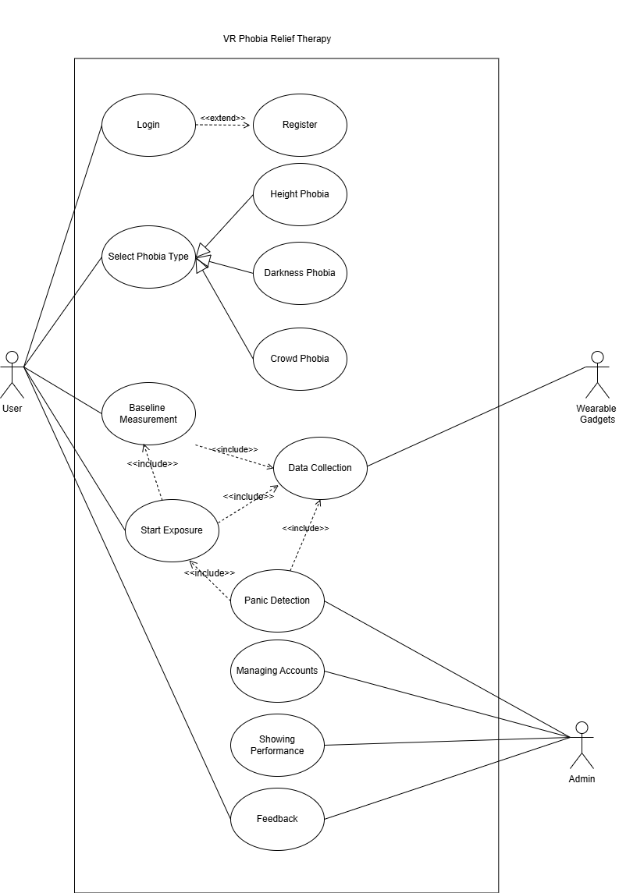
Figure 1: Use Case Diagram for Phobia Relief Therapy

4.2 High Level Cases

4.2.1 Login

Table 7: Login

Use case ID: | UC-01
Use case Name: | Login
Actor | User, Admin
Type: | Primary.
Description: | Registered users and admins log in to access their respective dashboards.
Extends: | Register

4.2.2 Register

Table 8: Register

Use case ID: | UC-02
Use case Name: | Register
Actor | User
Type: | Primary.
Description: | New users create an account by providing name, email and password

4.2.3 Select Phobia Type
Table 9: Select Phobia Type

Use case ID: | UC-03
Use case Name: | Select Phobia Type
Actor | User
Type: | Primary.
Description: | User browses available phobia therapy modules including Height Phobia, Darkness Phobia, and Crowd Phobia.
Includes: | Baseline Measurement, Start Exposure

4.2.4 Height Phobia
Table 10: Height Phobia

Use case ID: | UC-04
Use case Name: | Height Phobia(Specialization of Select Phobia Type)
Actor | User

Type: | Primary
Description: | User selects the Height Phobia therapy module. The system loads a virtual environment such as a balcony, bridge, or cliff with adjustable heights.

4.2.5 Darkness Phobia
Table 11: Darkness Phobia

Use case ID: | UC-05
Use case Name: | Darkness Phobia
Actor | User
Type: | Primary (Specialization of Select Phobia Type)
Description: | User selects the Darkness Phobia therapy module. The system loads a virtual environment with controlled exposure to darkness.

4.2.6 Crowd Phobia
Table 12: Crowd Phobia

Use case ID: | UC-06
Use case Name: | Crowd Phobia
Actor | User
Type: | Primary (Specialization of Select Phobia Type)
Description: | User selects the Crowd Phobia therapy module. The system loads a virtual environment with gradual exposure to crowds.

4.2.7 Baseline Measurement
Table 13: Baseline Measurement

Use case ID: | UC-07
Use case Name: | Baseline Measurement
Actor | System
Type: | Secondary ( Included in Select Phobia )
Description: | System records 1 minute of baseline heart rate and head movement data to establish normal levels for the user before each 2 minute exposure session begins.
Includes: | Data collection

4.2.8 Data Collection
Table 14: Data collection

Use case ID: | UC-08
Use case Name: | Data Collection
Actor | System
Type: | Secondary (Included in Select Phobia)
Description: | System collects heart rate data from Polar H10 gadget during the 1 minute baseline period.

4.2.9 Start Exposure
Table 15: Start Exposure

Use case ID: | UC-09
Use case Name: | Start Exposure
Actor | User
Type: | Primary
Description: | User begins VR exposure session after baseline measurement. System loads environment and starts session.
Includes: | Baseline Measurement, Data Collection

4.2.10 Panic Detection
Table 16: Panic Detection

Use case ID: | UC-10
Use case Name: | Panic Detection
Actor | System
Type: | Secondary
Description: | System calculates ΔHR, Head Movement score, and Time Spent to generate Panic Score. Uses (Decision Tree/Random Forest) to classify panic level and recommend action.

4.2.11 Feedback
Table 17: Feedback

Use case ID: | UC-11
Use case Name: | Feedback
Actor | User, Admin
Type: | Primary.
Description: | User can view real-time feedback during session.  Admin views anonymized system analytics including total sessions, average duration, and panic event statistics.

4.2.12 Analyze Performance
Table 18: Analyze Performance

Use case ID: | UC-12
Use case Name: | Feedback
Actor | Admin
Type: | Primary.
Description: | Admin views anonymized system analytics including session data, panic scores, and user progress.

4.2.13 Manage Accounts
Table 19: Manage Accounts

Use case ID: | UC-13
Use case Name: | Manage Accounts
Actor | Admin
Type: | Primary.
Description: | Admin can view, suspend, or delete user accounts.

Expanded Use Cases

Use Case 1: Login

Table 20: Login

Use case ID: | UC-01
Use case Name: | Login
Created by: | Ahmad Tayyab |  | Last updated by: | Ahmad Tayyab
Date Created: | 03/14/2026 |  | Revision Date: | 03/14/2026
Actor: |  | User, Admin
Description: |  | Registered users and admins log in to access their respective dashboards.
Trigger: |  | User or admin opens the application and selects Login.
Pre-condition: |  | User/admin has a registered account.
Post- condition: |  | User is redirected to User Dashboard. Admin is redirected to Admin Dashboard
Normal flow: |  | - User enters email and password.  - System validates credentials.  - System redirects to appropriate dashboard.

Alternative flow: | 2a. Invalid Credentials.  2a.1. System displays "Invalid email or password."  2a.2. User re-enters credentials.  2a.3. Return to step 1.
Exceptions: | Database connection error. No internet connectivity.
Includes: | N/A.
Frequency of use: | High
Special Requirements: | Secure password storage. Session management after login.

4.3.2 Use Case 2: Register

Table 21: Register

Use case ID: | UC-02
Use case Name: | Register
Created by: | Ahmad Tayyab |  | Last updated by: | Ahmad Tayyab
Date Created: | 03/14/2026 |  | Revision Date: | 03/14/2026
Actor: |  | User
Description: |  | New users create an account by providing name, email, and password.
Trigger: |  | User selects Register option from login screen.
Pre-condition: |  | User is not logged in.
Post- condition: |  | New user account is created and user is logged in.

Normal flow: |  | - User enters name, email, and password.  - System validates email format.  - System checks if email is unique.  - System creates account.  - System logs user in and redirects to dashboard..
Alternative flow: |  | 3a. Email already exists  3a.1. System displays "Email already registered."  3a.2. User chooses to login instead.  3a.3. Return to UC-01.
Exceptions: | Database error. Network failure
Includes: | N/A.
Frequency of use: | Medium
Special Requirements: | Password must meet security requirements. Email verification optional.

Use Case 3: Select Phobia Type

Table 22: Select Phobia Type

Use case ID: | UC-03
Use case Name: | Select Phobia Type
Created by: | Ahmad Tayyab |  | Last updated by: | Ahmad Tayyab
Date Created: | 03/14/2026 |  | Revision Date: | 03/14/2026
Actor: |  | User
Description: |  | User browses and selects a phobia type (Height, Darkness, or Crowd) for therapy.
Trigger: |  | User selects "Start New Session" from dashboard.
Pre-condition: |  | User is logged in.
Post- condition: |  | Phobia type is selected. System displays available difficulty levels.
Normal flow: |  | - System displays list of phobia types.  - User selects Height Phobia, Darkness Phobia, or Crowd Phobia.  - System confirms selection.  - System displays difficulty levels for selected phobia.
Alternative flow: |  | 2a. User cancels selection.  2a.1. User returns to dashboard
Exceptions: |  | N/A
Includes: |  | N/A.
Frequency of use: |  | High
Special Requirements: |  | Clear icons or descriptions for each phobia type

Use Case 4: Height Phobia

Table 23: Height Phobia

Use case ID: | UC-04
Use case Name: | Height Phobia
Created by: | Ahmad Tayyab |  | Last updated by: | Ahmad Tayyab
Date Created: | 03/14/2026 |  | Revision Date: | 03/14/2026
Actor: |  | User
Description: |  | User selects the Height Phobia therapy module. System loads a virtual environment such as a balcony, bridge, or cliff.
Trigger: |  | User selects Height Phobia from phobia list.
Pre-condition: |  | User is on Select Phobia Type screen.
Post- condition: |  | System loads height-based VR environment at selected difficulty.
Normal flow: |  | - User selects Height Phobia.  - System displays difficulty levels (Beginner, Intermediate, Advanced).  - User selects difficulty.  - System loads corresponding environment (Low Balcony, High Bridge, or Mountain Cliff)..

Alternative flow: | 3a. User changes mind.  3a.1. User goes back to phobia selection  3a.2. Return to UC-03
Exceptions: | Environment file missing. VR headset not detected.
Includes: | N/A
Frequency of use: | High.
Special Requirements: | Realistic height environments. Adjustable height levels.

4.3.5 Use Case 5: Darkness Phobia

Table 24: Darkness Phobia

Use case ID: | UC-05
Use case Name: | View AI Interpretation
Created by: | Ahmad Tayyab |  | Last updated by: | Ahmad Tayyab
Date Created: | 03/14/2026 |  | Revision Date: | 03/14/2026
Actor: |  | User
Description: |  | User selects the Darkness Phobia therapy module. System loads a virtual environment with controlled exposure to darkness.
Trigger: |  | User selects Darkness Phobia from phobia list
Pre-condition: |  | User is on Select Phobia Type screen.

Post- condition: | System loads Darkness-based VR environment at selected difficulty.
Normal flow: | - User selects Darkness Phobia.  - System displays difficulty levels (Beginner, Intermediate, Advanced).  - User selects difficulty.  - System loads corresponding environment
Alternative flow: | 3a. User changes mind.  3a.1. User goes back to phobia selection.  3a.2. Return to UC-03.
Exceptions: | Environment file missing. VR headset not detected.
Includes: | N/A
Frequency of use: | High
Special Requirements: | Realistic Dark Themed Stages with sounds. Gradual exposure control.

Use Case 6: Crowd Phobia

Table 25: Crowd Phobia

Use case ID: | UC-06
Use case Name: | Crowd Phobia
Created by: | Ahmad Tayyab |  | Last updated by: | Ahmad Tayyab
Date Created: | 03/14/2026 |  | Revision Date: | 03/14/2026
Actor: |  | User
Description: |  | User selects the Crowd Phobia therapy module. System loads a virtual environment with gradual exposure to crowds.
Trigger: |  | User selects Crowd Phobia from phobia list.
Pre-condition: |  | User is on Select Phobia Type screen.

Post- condition: | System loads crowd-based VR environment at selected difficulty.
Normal flow: | - User selects Crowd Phobia.  - System displays difficulty levels (Beginner, Intermediate, Advanced).  - User selects difficulty.  - System loads corresponding environment (Small group, Medium crowd, Large audience).
Alternative flow: | 3a. User changes mind.  3a.1. User goes back to phobia selection.  3a.2. Return to UC-03.
Exceptions: | Environment file missing. VR headset not detected.
Includes: | N/A
Frequency of use: | High
Special Requirements: | Realistic crowd animations. Adjustable crowd density.

Use Case 7: Baseline Measurement

Table 26: Baseline Measurement

Use case ID: | UC-07
Use case Name: | Baseline Measurement
Created by: | Ahmad Tayyab |  | Last updated by: | Ahmad Tayyab
Date Created: | 03/15/2026 |  | Revision Date: | 03/15/2026
Actor: |  | System
Description: |  | System records 1 minute of baseline heart rate and head movement data (rotation speed and movement frequency) to establish normal levels for the user before each 2 minute exposure session begins.
Trigger: |  | User clicks "Start Session" after selecting phobia.
Pre-condition: |  | Phobia type and difficulty level are selected. VR headset is connected.
Post- condition: |  | Baseline heart rate (average) is recorded and stored for this session.
Normal flow: |  | - System prompts user to remain calm for 1 minute..  - System triggers UC-08 (Data Collection).  - System collects heart rate data every second for 1 minute.  - System collects head movement data:  - Rotation speed (degrees per second)  - Movement frequency (position changes per second).  - After 2 minutes, system calculates:  - Average baseline HR  - Average baseline head movement score.  - System stores baseline data with session record.  - System notifies user that baseline is complete.  - System prompts user to proceed to UC-09 (Start Exposure)

Alternative flow: | 3a. Gadget disconnects during baseline.  3a.1. System pauses baseline.  3a.2. System prompts user to reconnect.  3a.3. Upon reconnection, baseline restarts from beginning.  3a.4. Return to step 1.
Exceptions: | VR headset disconnects. Gadget battery low.
Includes: | UC-08 (Data Collection) is triggered automatically.
Frequency of use: | High
Special Requirements: | Clear instructions for user to remain still and calm for 1 minute.

Use Case 8: Data Collection and AI recommendation

Table 27: Data Collection

Use case ID: | UC-08
Use case Name: | Data Collection
Created by: | Shehroz Abbas |  | Last updated by: | Ahmad Tayyab
Date Created: | 03/15/2026 |  | Revision Date: | 03/15/2026
Actor: |  | Wearable Gadgets
Description: |  | The Polar H10 gadget sends heart rate data and head movement data (rotation speed, movement frequency) to system during baseline and exposure sessions. The Data is used to predict stress and stage.
Trigger: |  | Baseline Measurement starts (UC-07) or Start Exposure begins (UC-09).
Pre-condition: |  | Gadget is paired and connected via Bluetooth. VR headset is tracking.
Post- condition: |  | Heart rate and behavioral data are collected and stored.
Normal flow: |  | - Gadget detects user's heart rate every second.  - VR headset tracks head movement:  - Rotation speed (degrees per second)  - Movement frequency (position changes per second).  - Gadget transmits data to system.  - System receives and timestamps:  - Heart rate reading  - Rotation speed  - Movement frequency.  - System stores data with session ID and timestamp.  - This continues for duration of baseline or exposure.  - AI predicts and suggests user whether to stay on the same stage or move to next.

Alternative flow: | 2a. Connection lost.  2a.1. System detects disconnection.  2a.2. System pauses data collection.  2a.3. System notifies user to reconnect.  2a.4. Upon reconnection, collection resumes.
Exceptions: | Bluetooth interference. Gadget battery dies. Headset tracking loss.
Includes: | N/A.
Frequency of use: | Continuous during every session.
Special Requirements: | Low latency transmission. Accurate timestamping.

Use Case 9: Start Exposure

Table 28: Start Exposure

Use case ID: | UC-09
Use case Name: | Feedback
Created by: | Sehar Saleem |  | Last updated by: | Ahmad Tayyab
Date Created: | 03/15/2026 |  | Revision Date: | 03/15/2026
Actor: |  | User
Description: |  | User begins VR exposure session after baseline measurement. System loads environment and starts session.
Trigger: |  | User selects "Start" after baseline measurement completes.
Pre-condition: |  | Phobia type is selected. Baseline data is recorded. VR headset and gadget are connected.
Post- condition: |  | VR environment loads and session begins. Panic Detection is active.

Normal flow: | - System confirms gadget connection.  - System loads VR environment based on selected phobia and difficulty.  - User is placed in safe room.  - Countdown displays.  - User enters exposure environment.  - Session timer starts.  - System triggers UC-08 (Data Collection).  - System triggers UC-10 (Panic Detection).  - Session continues for duration.  - After session ends, user returns to safe room
Alternative flow: | 1a. Gadget not connected.  1a.1. System prompts user to connect.  1a.2. User connects gadget.  1a.3. Return to step 1.  3a. User feels unready.  3a.1. User can remain in safe room.  3a.2. User exits session when ready.  9a. Panic detected during session (via UC-10).  9a.1. Safety mechanisms may end session early.  9a.2. User returns to safe room.
Exceptions: | VR headset disconnects. Gadget battery low.
Includes: | UC-08, UC-10
Frequency of use: | Every Session.
Special Requirements: | Clear timer display. Easy exit option always available.

Use Case 10: Panic Detection

Table 29: Panic Detection

Use case ID: | UC-10
Use case Name: | Track Reports
Created by: | Sehar Saleem |  | Last updated by: | Shehroz Abbas
Date Created: | 03/15/2026 |  | Revision Date: | 03/16/2026
Actor: |  | System
Description: |  | System calculates ΔHR, Head Movement score, and Time Spent to generate Panic Score. Uses AI (Decision Tree/Random Forest) to classify panic level and recommend action.
Trigger: |  | Start Exposure begins (UC-09).
Pre-condition: |  | Baseline data exists. Current HR and movement data are being received from UC-08.
Post- condition: |  | Panic event is logged if detected. AI recommendation is generated. Safety action may be triggered.
Normal flow: |  | - System receives current data every second from UC-08:  - Heart rate  - Rotation speed  - Movement frequency  - System calculates ΔHR = Current HR - Baseline HR.  - System calculates Head Movement (HM) Score:  - Combines rotation speed and movement frequency  - Scaled to 0-100 based on deviation from baseline  - System calculates Time Spent (TS) Score:  - Tracks consecutive seconds where HR or movement exceeds thresholds  - If panic time < 15 seconds → high stress  - Scaled to 0-100  - System computes Panic Score = (ΔHR × 0.5) + (HM × 0.3) + (TS × 0.2).  - If ΔHR > 25, system flags as high priority.  - System sends Panic Score to AI model (Decision Tree/Random Forest).  - AI model classifies panic level:  - 0 - 10: Calm stress → AI recommends "Continue Exposure"  - 10 - 18: Panic detected → AI recommends "Repeat Level"  - 18+: Severe panic → AI recommends "Stop / Safe Room"  - System logs panic event with:  - Timestamp  - ΔHR value  - Head Movement Score  - Time Spent Score  - Calculated Panic Score  - AI classification  - AI recommendation  - If score ≥ 18, system triggers safety mechanism.  - System continues monitoring until session ends.

Alternative flow: | 10a. Safety mechanism triggered.  10a.1. System pauses exposure.  10a.2. System teleports user to safe room.  10a.3. Session ends.
Exceptions: | Database error. Permission denied.
Includes: | N/A
Frequency of use: | Every second during every session.
Special Requirements: | Low latency processing. AI model trained on panic data.

Use Case 11: Feedback

Table 30: Feedback

Use case ID: | UC-11
Use case Name: | Showing Performance
Created by: | Ahmad Tayyab |  | Last updated by: | Ahmad Tayyab
Date Created: | 03/16/2026 |  | Revision Date: | 03/16/2026
Actor: |  | User, Admin
Description: |  | Admin views anonymized system analytics including total sessions, average duration, and panic event statistics.  User views session feedback including Panic Scores, heart rate graph, and AI recommendations.
Trigger: |  | Session ends (completed, paused, or aborted).
Pre-condition: |  | Session data has been recorded.
Post- condition: |  | Feedback is displayed to user and saved to session history.
Normal flow: |  | - System retrieves session data.  - System calculates statistics:  - Session duration  - Baseline HR  - Peak heart rate  - Average heart rate  - Number of panic events  - Average Panic Score  - Highest Panic Score  - AI recommendations per panic event  - Graph of heart rate over time  - System displays feedback screen.  - User views feedback.  - User submits feedback.  - System saves feedback to database.

Alternative flow: | 5a. User skips rating.  5a.1. Feedback is saved without rating.  6a. User skips comments.  6a.1. Feedback is saved without comments.
Exceptions: | Database error.
Includes: | N/A.
Frequency of use: | Every session.
Special Requirements: | Clear visual graphs showing Panic Score and AI recommendations.

Use Case 12: Analyze Performance

Table 31: Analyze Performance

Use case ID: | UC-11
Use case Name: | Analyze Performance
Created by: | Ahmad Tayyab |  | Last updated by: | Ahmad Tayyab
Date Created: | 03/16/2026 |  | Revision Date: | 03/16/2026
Actor: |  | Admin
Description: |  | Admin views anonymized system analytics including total sessions, average duration, and panic event statistics.
Trigger: |  | Admin selects "Performance" from admin dashboard.
Pre-condition: |  | Admin is logged in.
Post- condition: |  | Performance data is displayed.
Normal flow: |  | - System retrieves anonymized session data.  - System calculates statistics:  - Total number of sessions  - Average session duration  - Sessions per phobia type  - Average baseline HR across users  - Average head movement patterns  - Average Panic Score across all sessions  - Total panic events  - Average panic events per session  - System generates charts and graphs.  - System displays performance dashboard.  - Admin views data.  - Admin may filter by date range or phobia type

Alternative flow: | 2a. No data available.  2a.1. System displays "No session data found."
Exceptions: | Database error.
Includes: | N/A.
Frequency of use: | Medium
Special Requirements: | Clear visual charts. Data must be anonymized. AI performance metrics.

Use Case 13: Manage Accounts

Table 32: Manage Accounts

Use case ID: | UC-11
Use case Name: | Analyze Performance
Created by: | Ahmad Tayyab |  | Last updated by: | Ahmad Tayyab
Date Created: | 03/16/2026 |  | Revision Date: | 03/16/2026
Actor: |  | Admin
Description: |  | Admin can view, suspend, or delete user accounts.
Trigger: |  | Admin selects "Manage Users" from admin dashboard.
Pre-condition: |  | Admin is logged in.
Post- condition: |  | User accounts are updated based on admin actions.
Normal flow: |  | - System displays list of all users.  - Admin selects a user.  - Admin views user details.  - Admin chooses action:  - Suspend account  - Activate account  - Delete account  - System confirms action.  - System updates database.  - System logs the action.
Alternative flow: |  | 4a. Admin edits user details.  4a.1. Admin updates email or name.  4a.2. System saves changes.  4a.3. Return to step 5.
Exceptions: |  | Database error.
Includes: |  | N/A.
Frequency of use: |  | Low
Special Requirements: |  | Audit log for all admin actions. Confirmation before deletion.

System Sequence Diagrams

4.4.1 Login
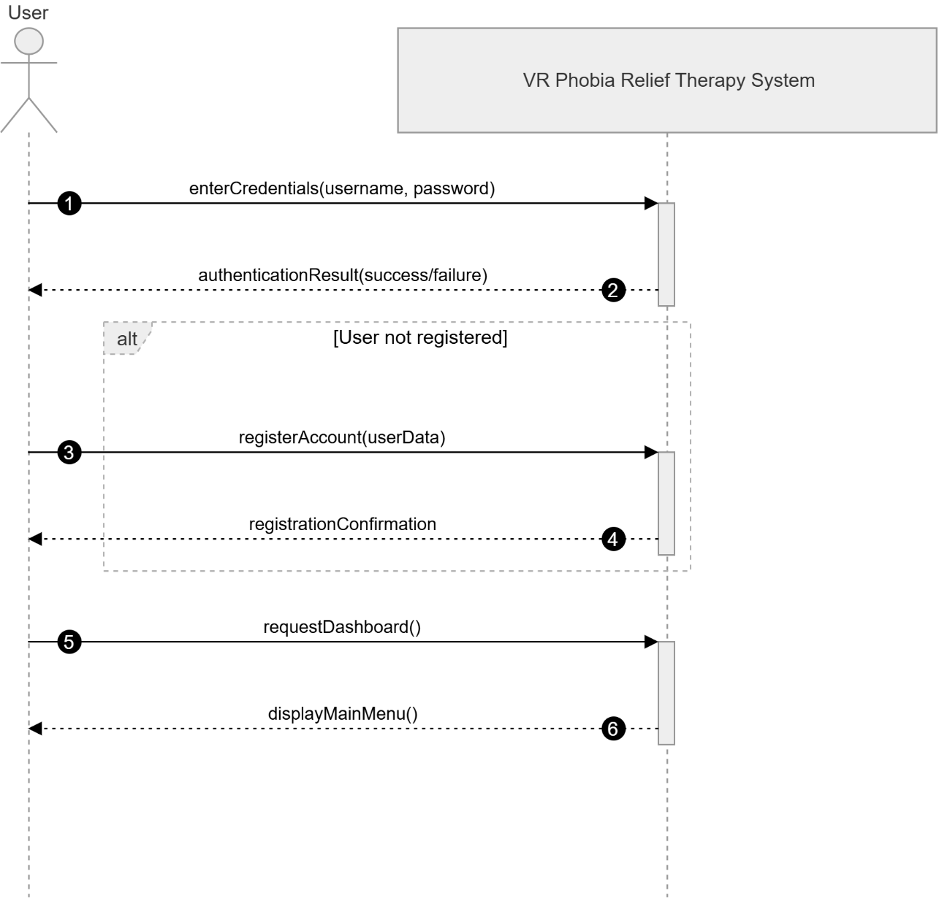

Figure 2: SSD for Login PHOBIA RELIEF THERAPY

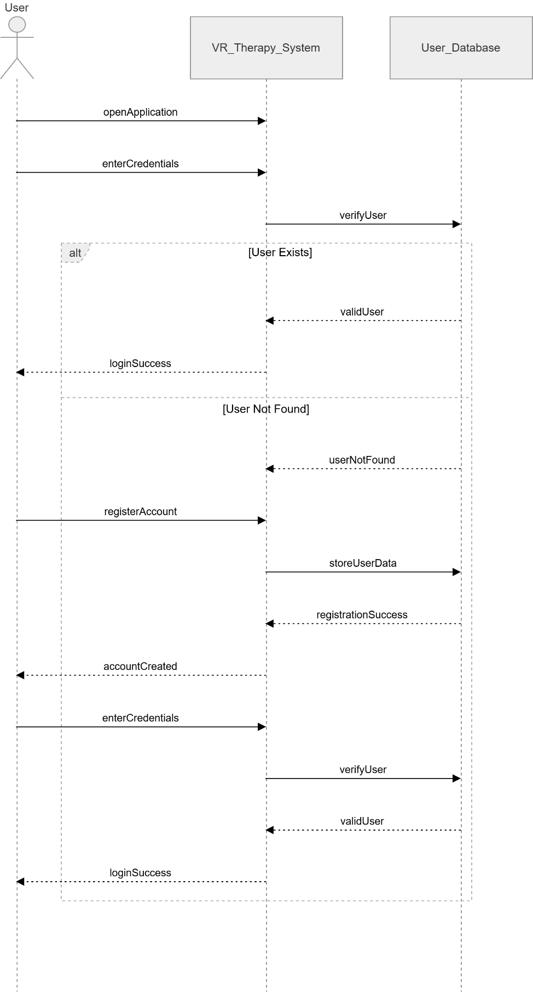
4.4.2 Register
Figure 3 SSD for Register PHOBIA RELIEF THERAPY

4.4.3 Select Phobia Type
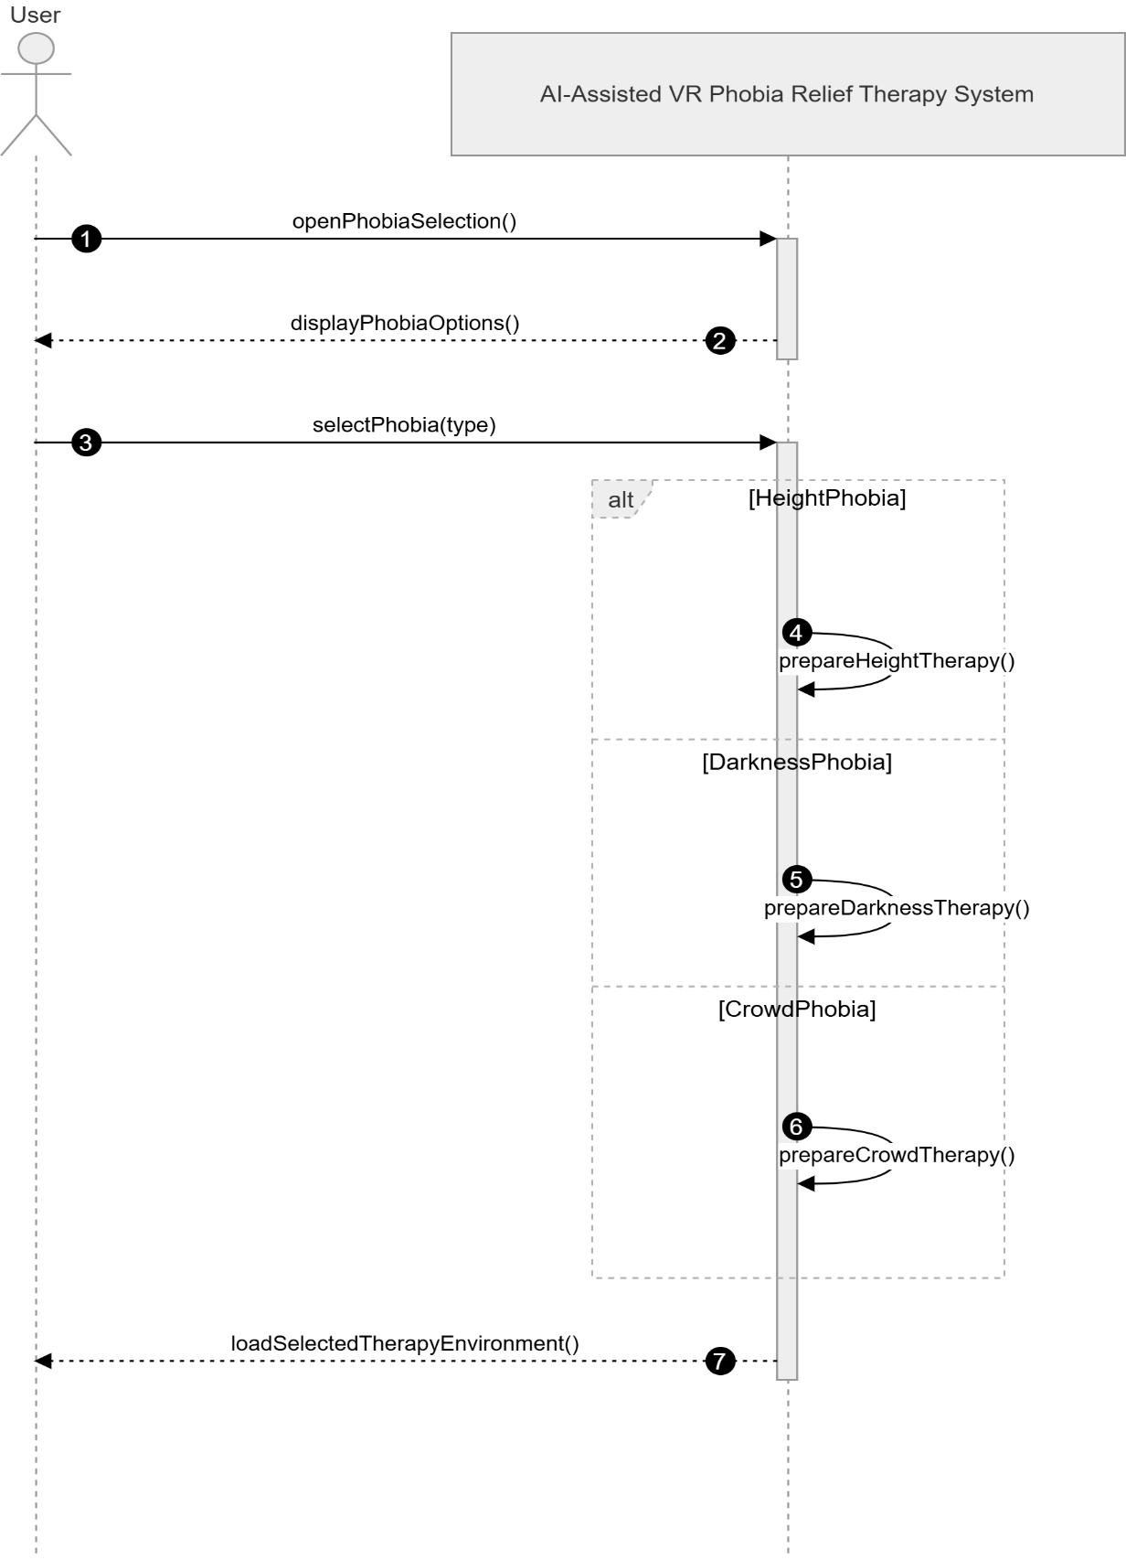
Figure 4: SSD for Select Phobia PHOBIA RELIEF THERAPY
Figure 4: SSD for Track Report

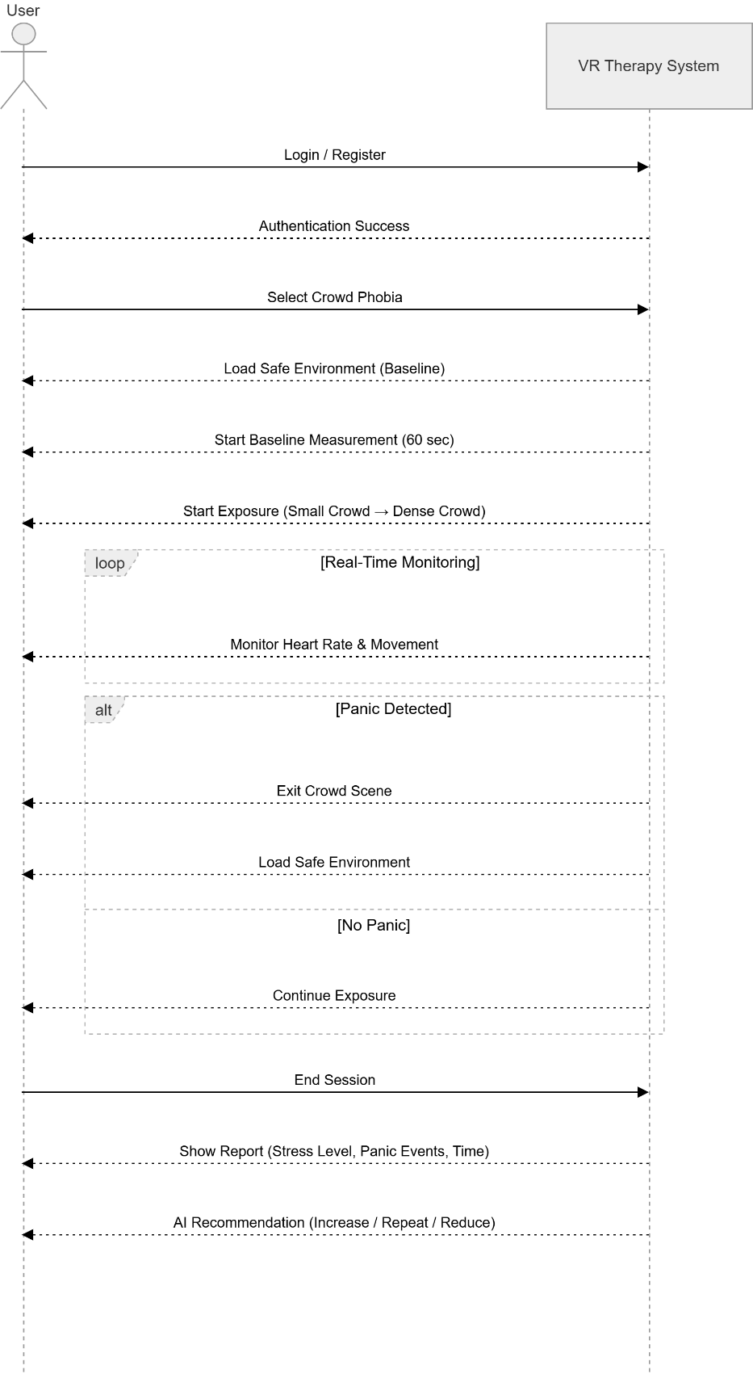
4.4.4 Crowd Phobia
Figure 5 SSD for Crowd Phobia PHOBIA RELIEF THERAPY

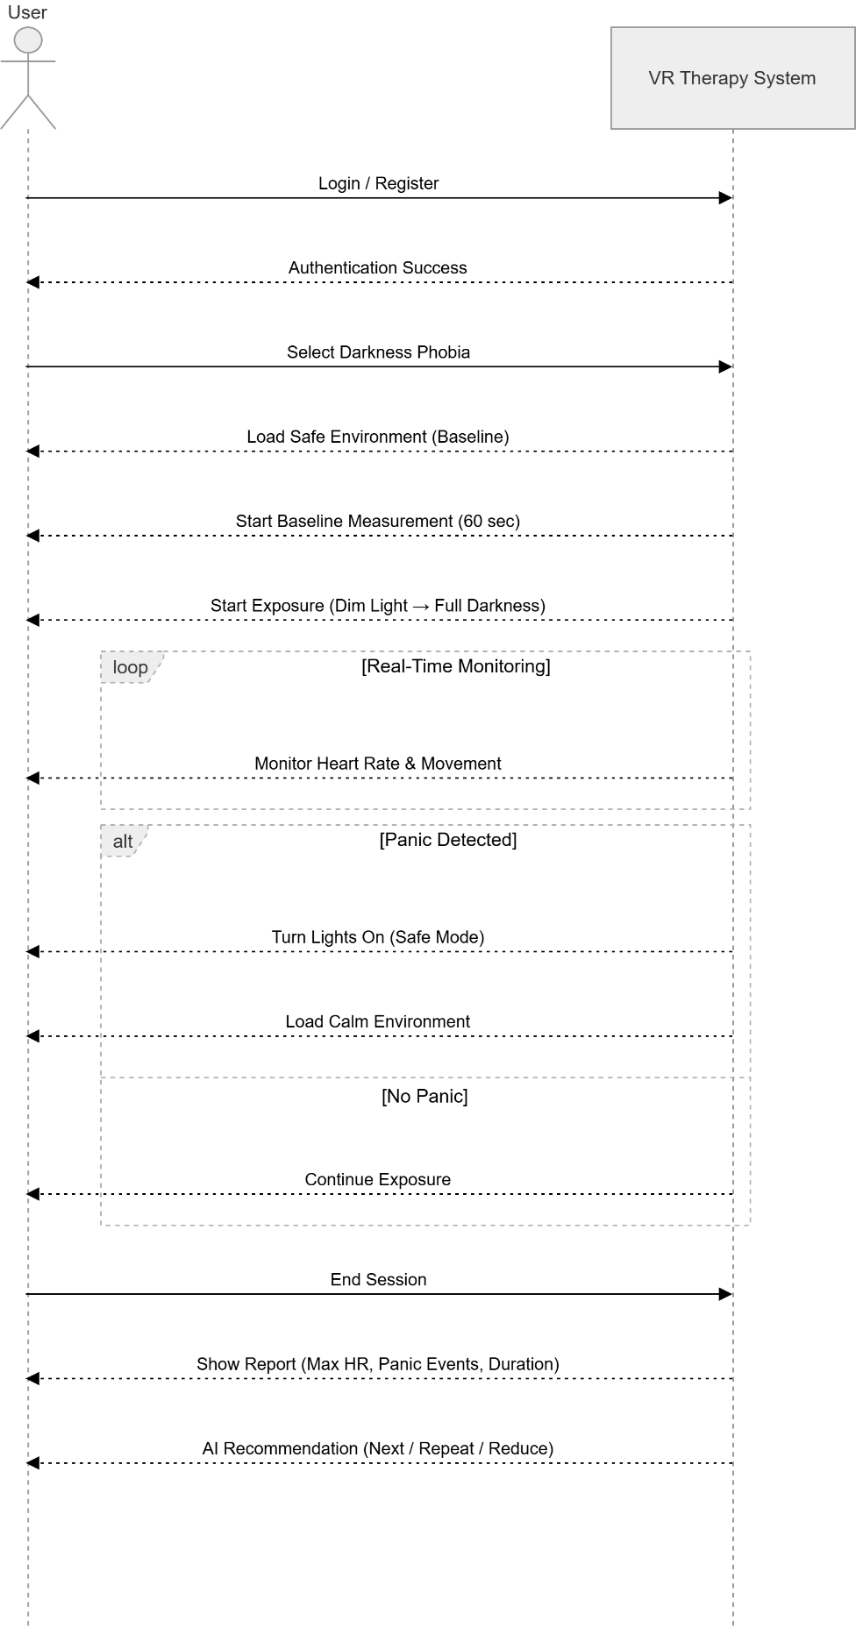
4.4.5 Darkness Phobia
Figure 6 SSD for Darkness Phobia PHOBIA RELIEF THERAPY

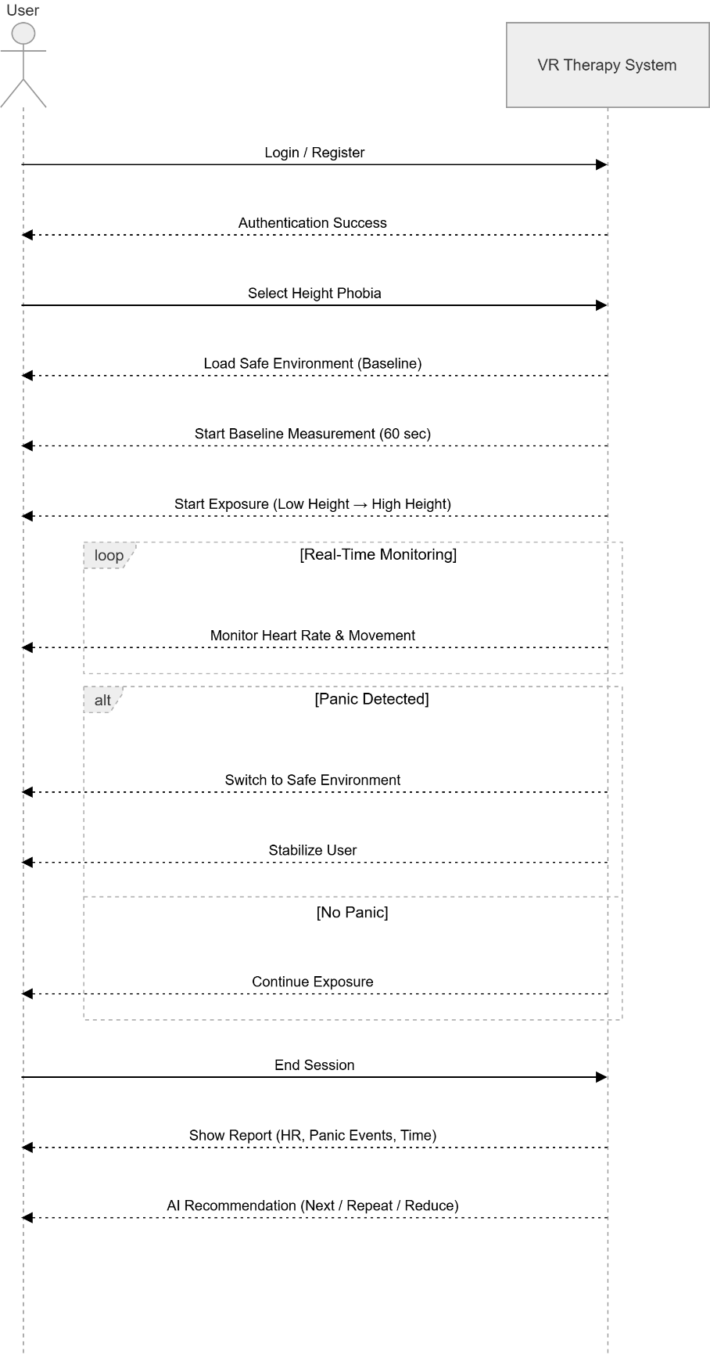
4.4.6 Height Phobia
Figure 7 SSD for Height Phobia PHOBIA RELIEF THERAPY

4.4.7 Baseline Measurement

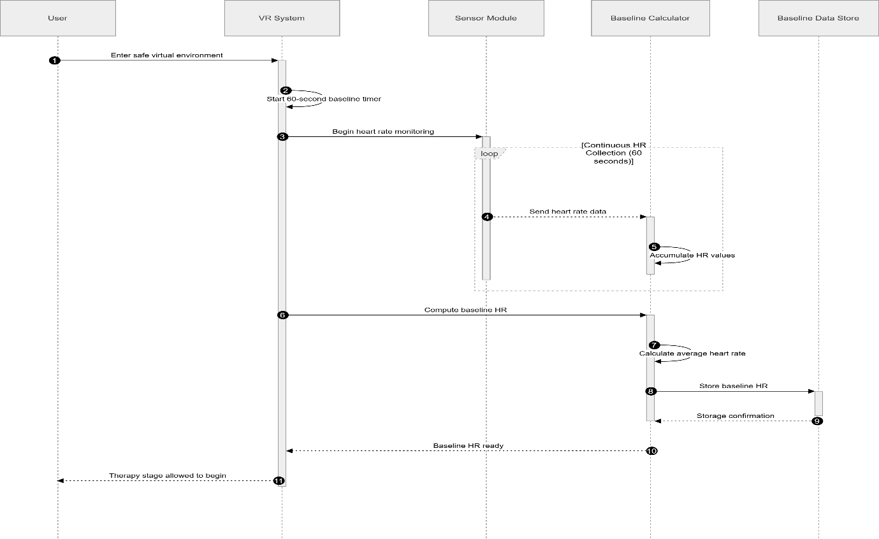
Figure 8: Baseline Measurement

4.4.8 Data Collection And AI recommendation
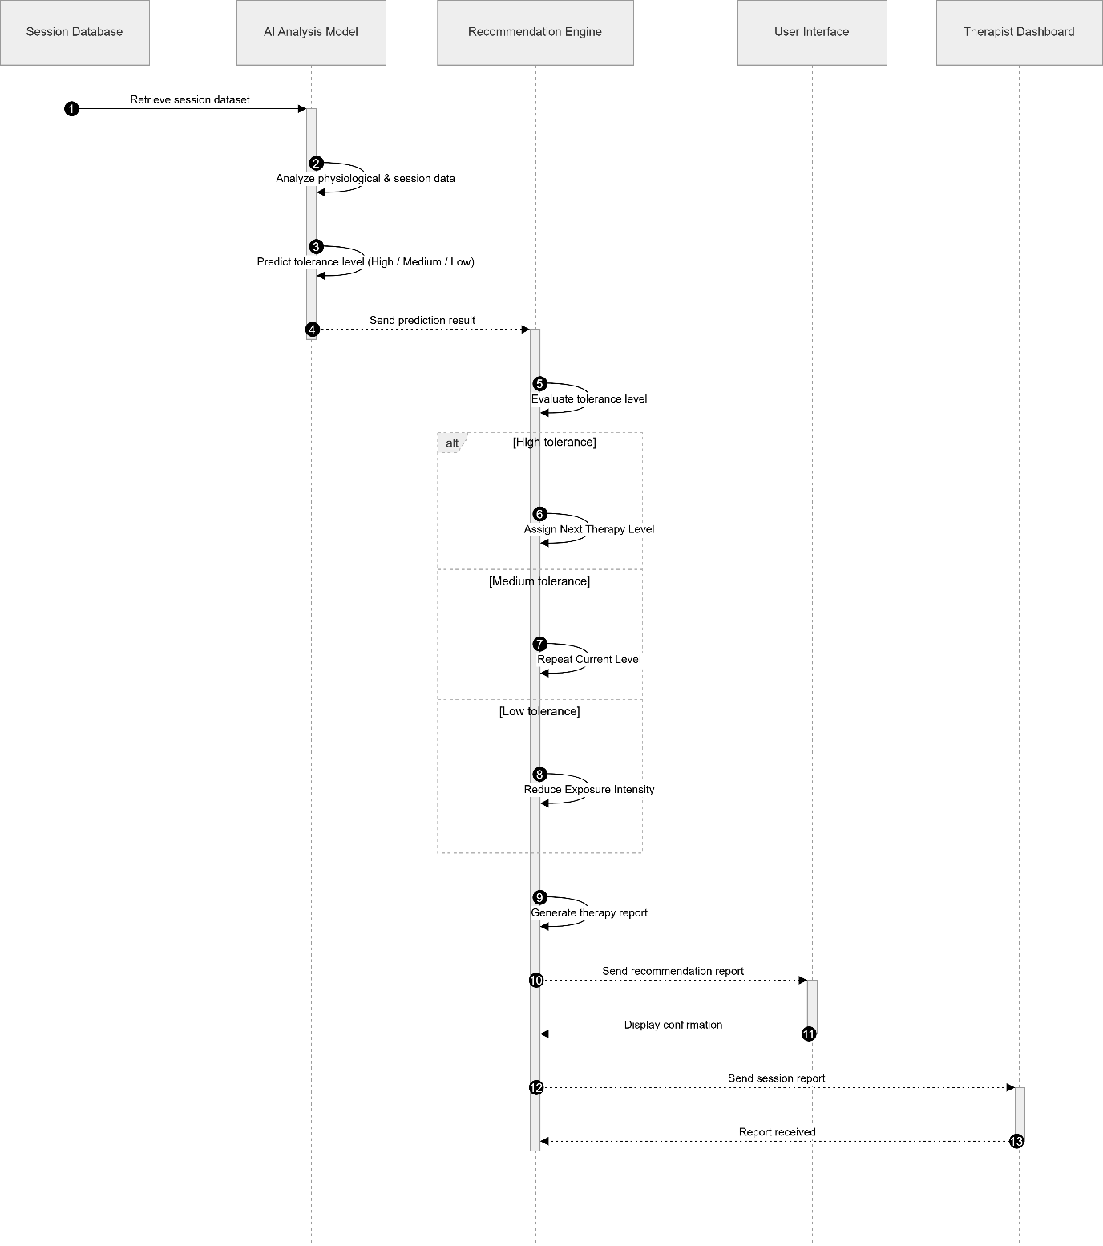
Figure 9 Data Collection and AI Suggestion PHOBIA RELIEF THERAPY

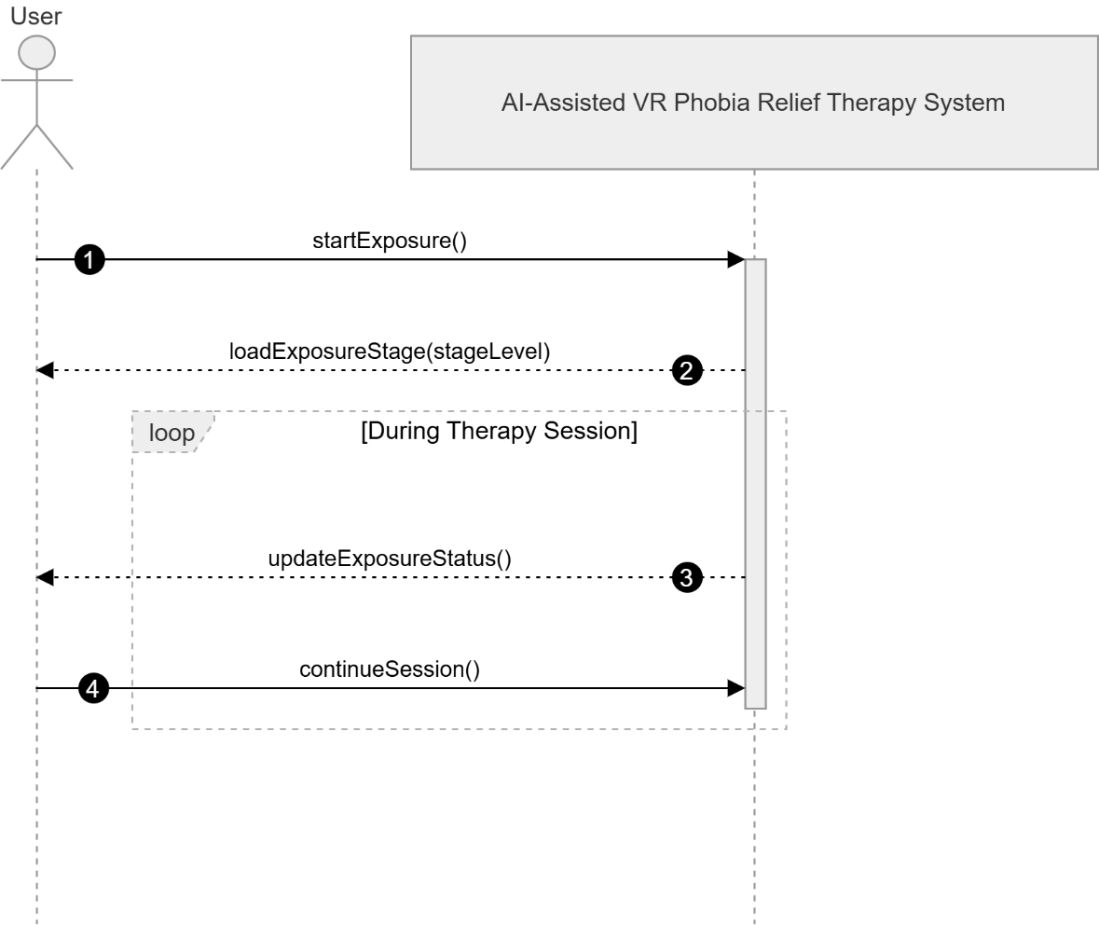
4.4.9 Start Exposure
Figure 10 SSD for Start Exposure PHOBIA RELIEF THERAPY

4.4.10 Panic Detection
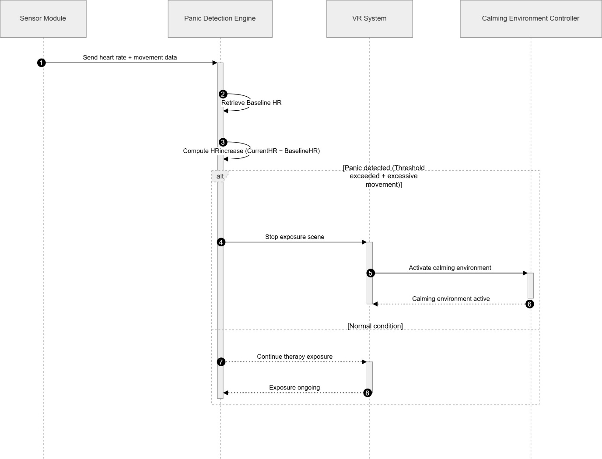
Figure 11 SSD for Panic Detection PHOBIA RELIEF THERAPY

4.4.11 Feedback
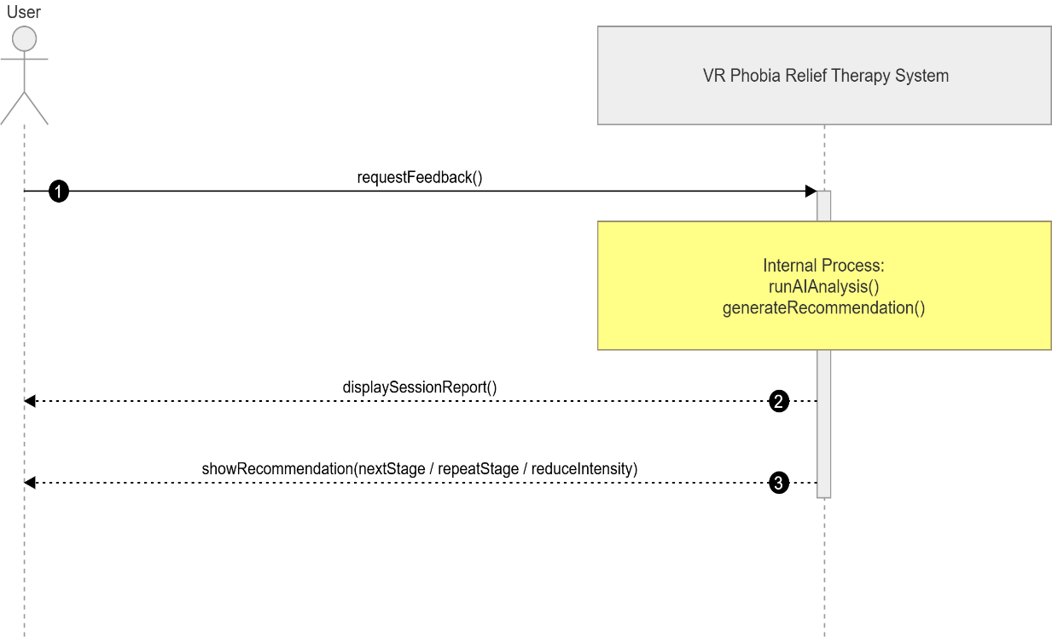
Figure 12 SSD for Feedback PHOBIA RELIEF THERAPY

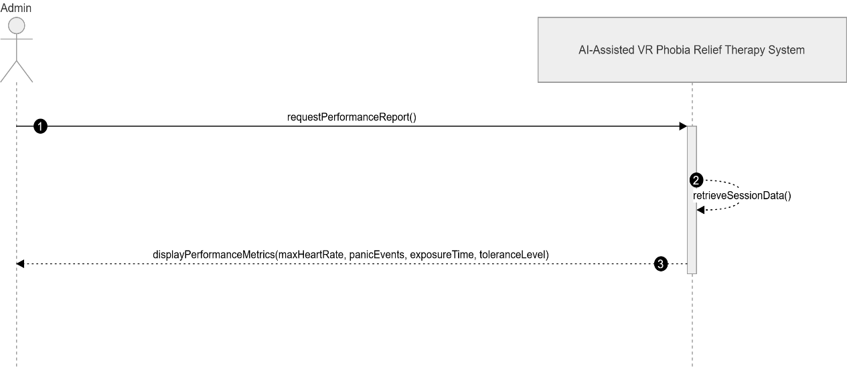
4.4.12 Analyze Performance
Figure 13 SSD for Analyze Performance PHOBIA RELIEF THERAPY

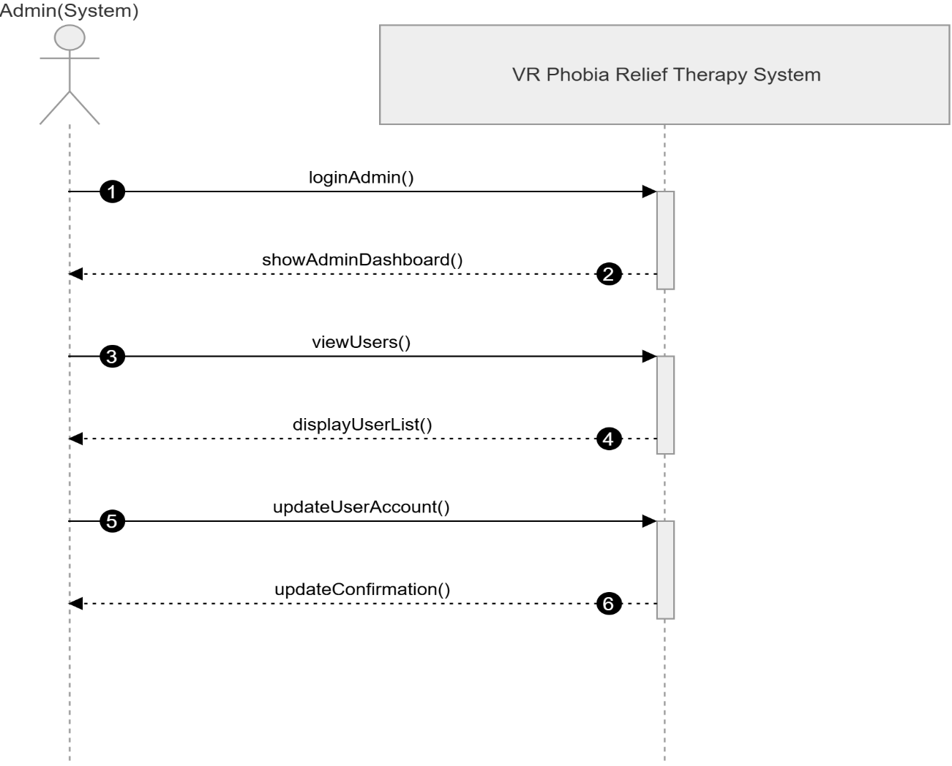
4.4.13 Manage Accounts
Figure 14 SSD for Manage Accounts PHOBIA RELIEF THERAPY

Activity Diagram

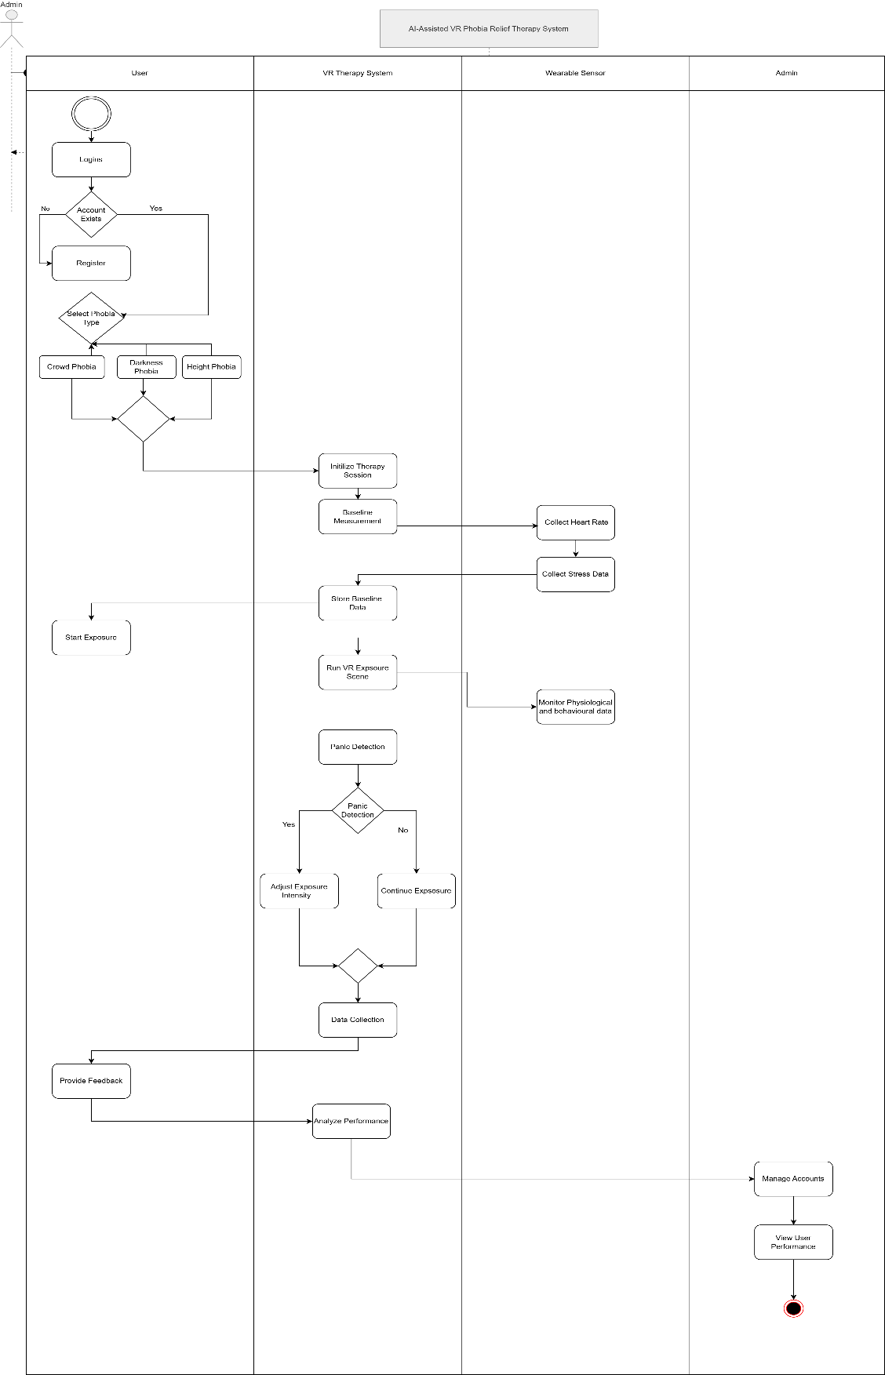
Figure 15 : Activity Diagram for PHOBIA RELIEF THERAPY

Class Diagram
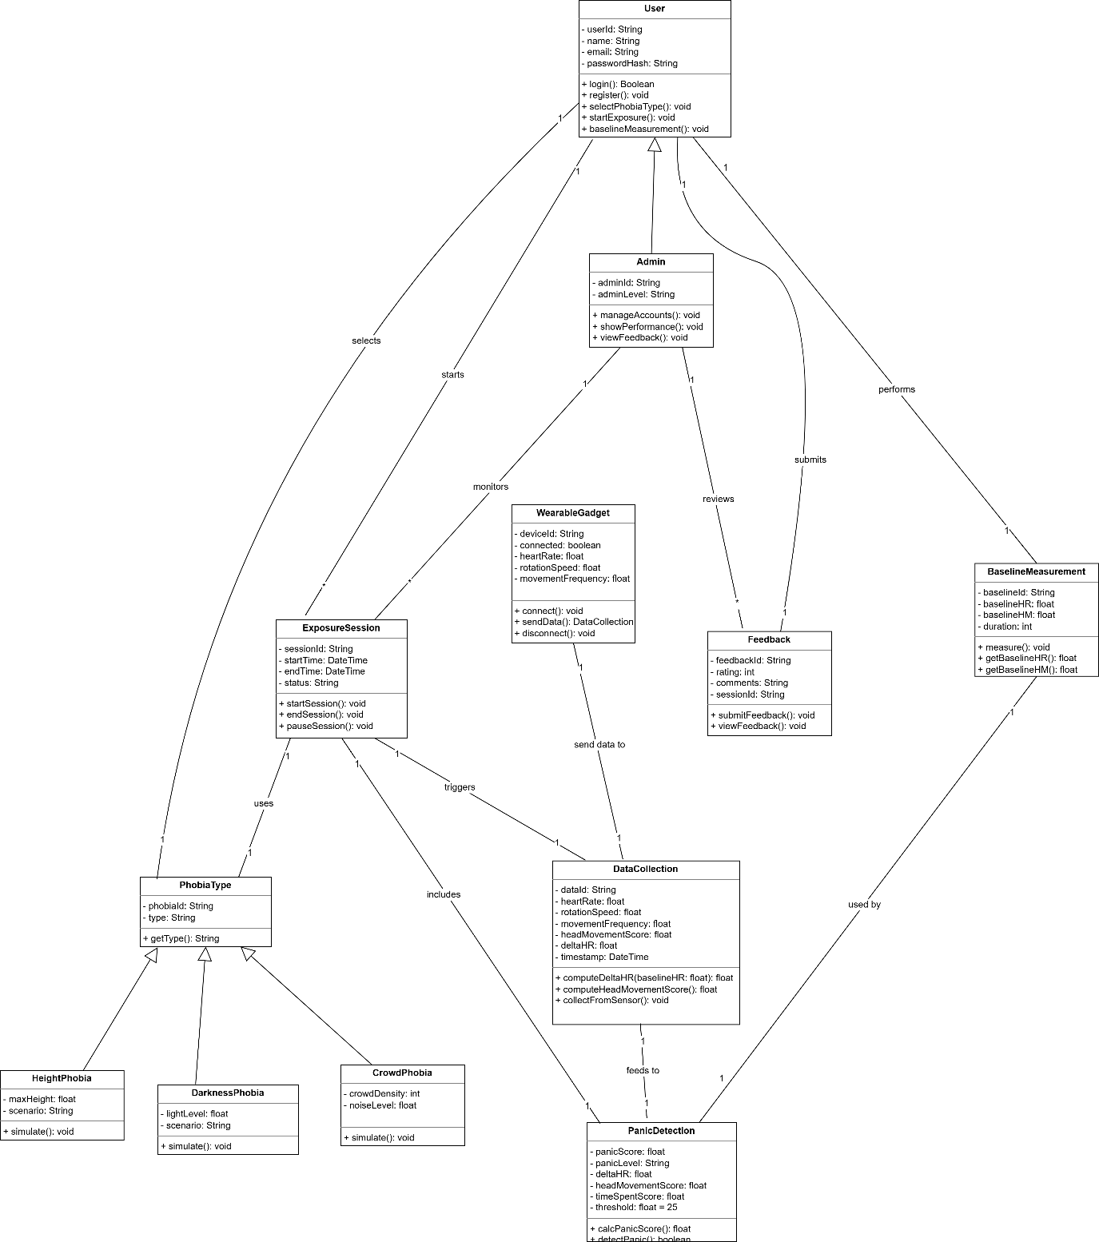
Figure 16: Class Diagram for PHOBIA RELIEF THERAPY

Domain Model
Figure 17: Domain Model for PHOBIA RELIEF THERAPY
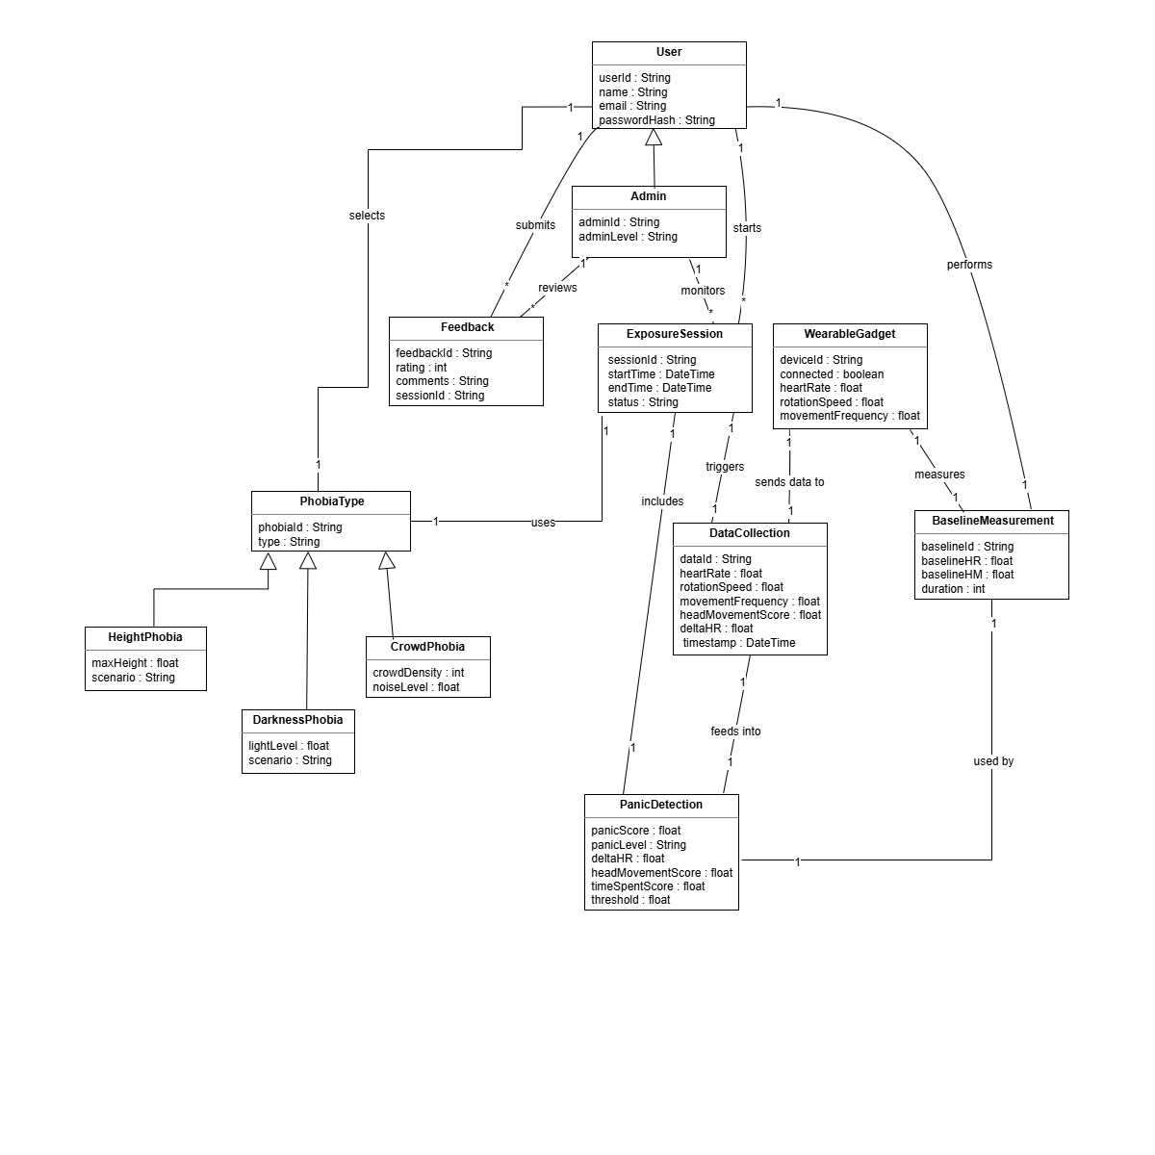


Package Diagram
Figure 18 : Package Diagram for PHOBIA RELIEF THERAPY

Schema

4.9.1 User Schema
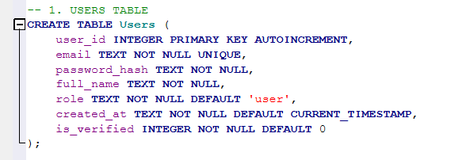
Figure 19 User Schema

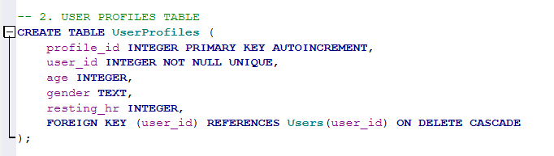
4.9.2 User Profile Schema
Figure 20 User Profile Schema

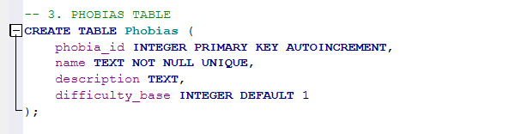
4.9.3 Phobias Schema
Figure 21 Phobias Schema

4.9.4 VR Environments Schema
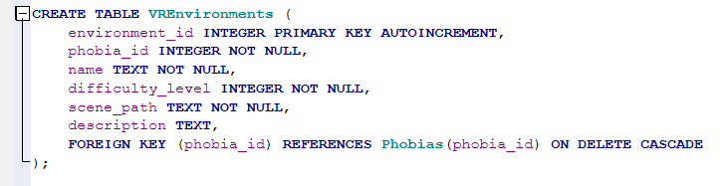
Figure 22 VR Environments Schema

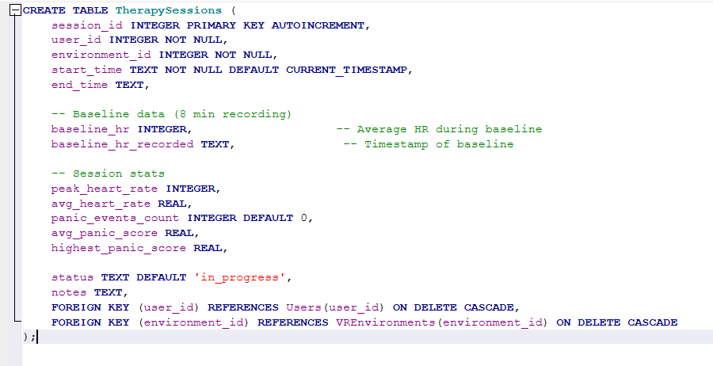
4.9.5 Therapy Session Schema
Figure 23 Therapy Session Schema

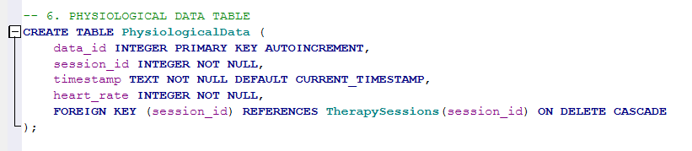
4.9.6 Physiological Data Schema
Figure 24 Physiological Data Schema

4.9.7 Panic Events Schema
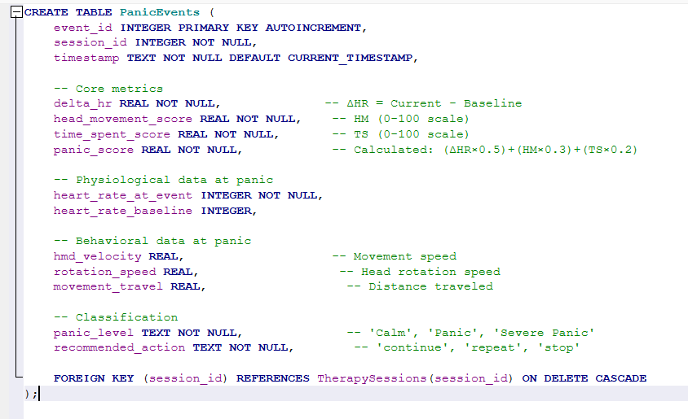
Figure 25 Panic Event Schema

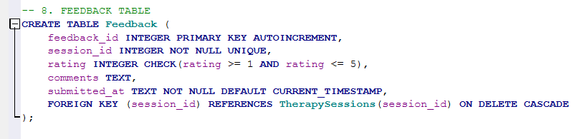
4.9.8 Feedback Schema
Figure 26 Feedback Schema

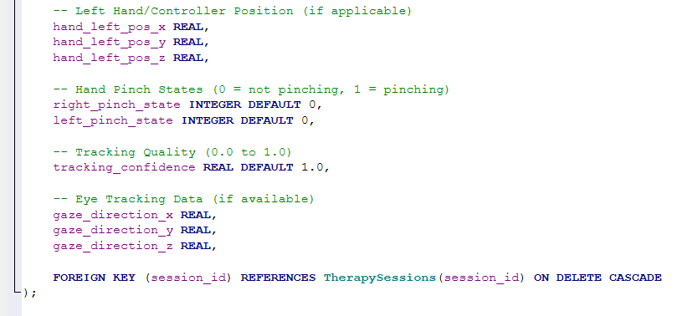
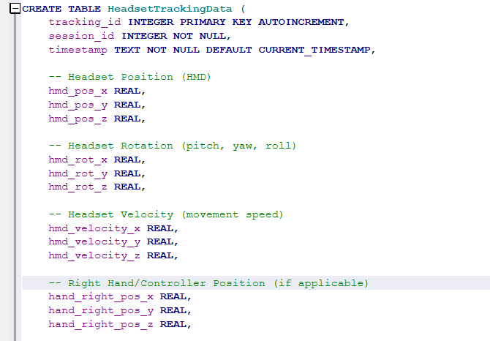
4.9.9 Headset Tracking Schema
Figure 27 Headset Tracking Schema

Data Flow Diagrams

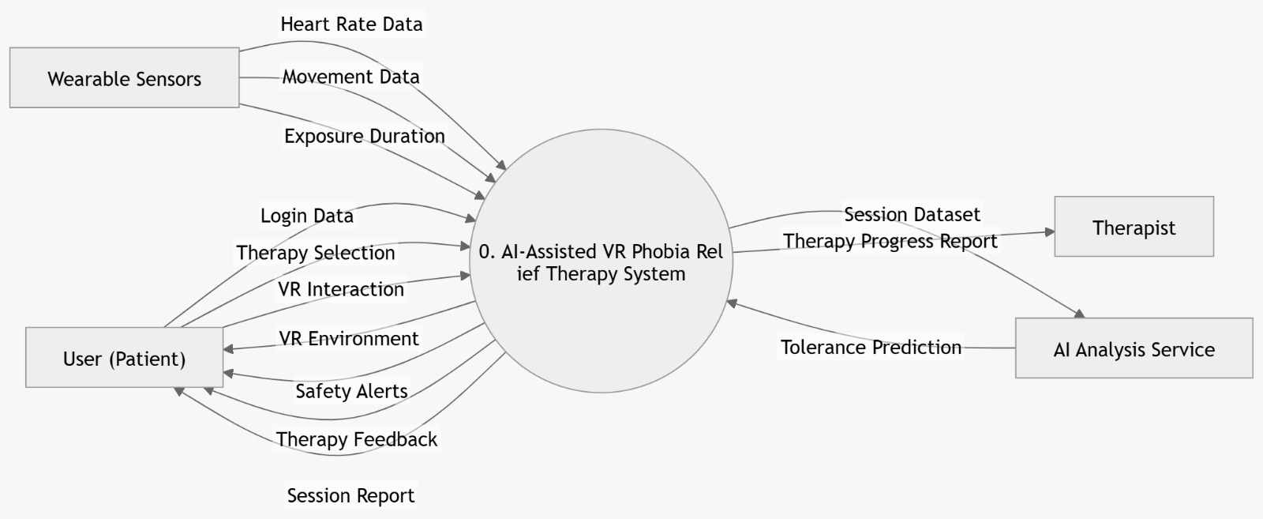
4.10.1Data Flow Diagram: Level 0
Figure 28 DFD Level 0 PHOBIA RELIEF THERAPY

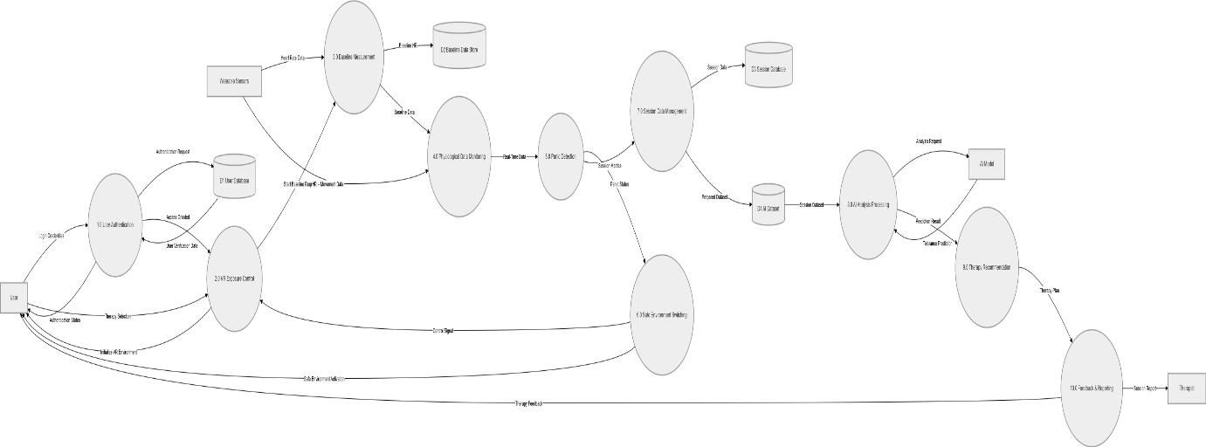
4.10.2 Data Flow Diagram : Level 1
Figure 29 DFD Level 2 PHOBIA RELIEF THERAPY

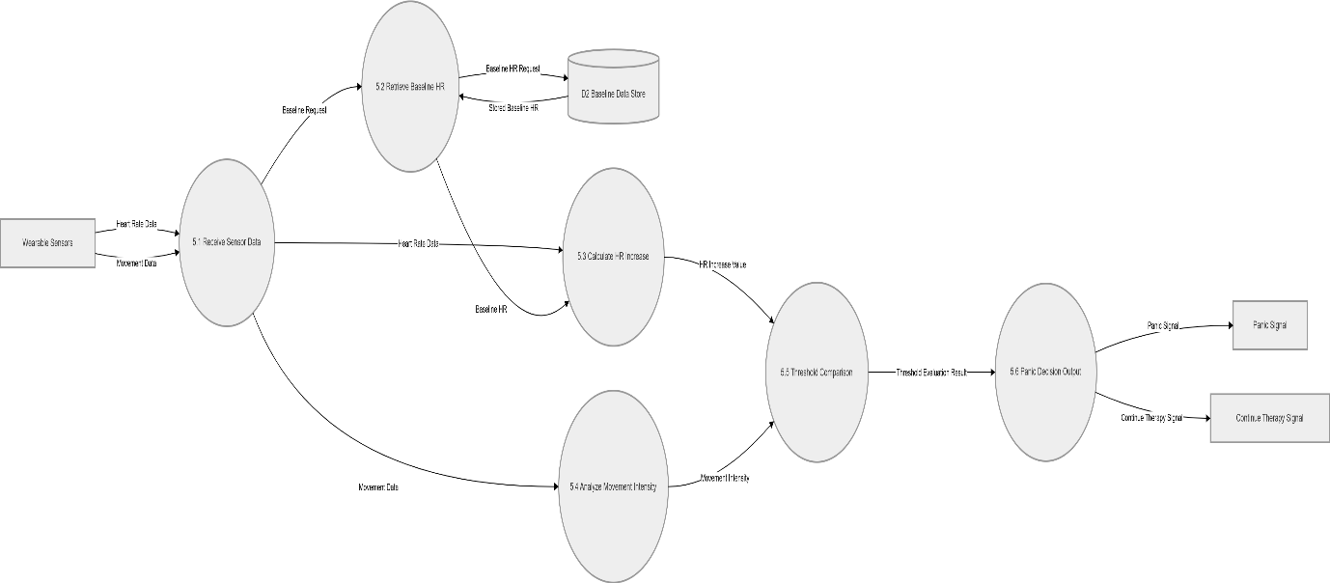
4.10.3 Data Flow Diagram: Level 2
Figure 30 DFD Level 3 PHOBIA RELIEF THERAPY

References

[1] Morina, N., Ijntema, H., Meyerbröker, K., & Emmelkamp, P. M. G. (2015). Can virtual reality exposure therapy gains be generalized to real-life? A meta-analysis of studies applying behavioral assessments. Behaviour Research and Therapy, 74, 18-24.
[2] Opriş, D., Pintea, S., García-Palacios, A., et al. (2012). Virtual reality exposure therapy in anxiety disorders: A quantitative meta-analysis. Depression and Anxiety, 29(2), 85-93.
[3] Powers, M. B., & Emmelkamp, P. M. G. (2008). Virtual reality exposure therapy for anxiety disorders: A meta-analysis. Journal of Anxiety Disorders, 22(3), 561-569.
Physiological Monitoring in VR Therapy
[4] Polar Electro. (2023). Polar H10 heart rate sensor: Bluetooth developer guide. Kempele, Finland: Polar Electro Oy. Retrieved from https://developer.polar.com
[5] Polar Electro. (2022). Polar H10 user manual: Heart rate monitoring and data accuracy. Kempele, Finland: Polar Electro Oy.

